Adventist University of Central Africa (AUCA)
PROJECT 2 – FINAL REPORT
Mobile Money Investigations with PostgreSQL and Neo4j
Relational versus graph models for connected-account analysis on 20 million transfers
Programme | MSc Big Data Analytics
Course | Big Data Analytics
Course code | MSDA9215
Lecturer | Temitope Oguntade
Submitted by
Member | Student ID | Main responsibility
Mushambo Godfrey | 101376 | Setting up the environment
Manzi Shima Christian | 101382 | Script formatting
Mutoni Scovia | 101374 | Interpreting the results
GitHub repository: https://github.com/Mushambo/mobile-money-project
Kigali, Rwanda – October 2026

Table of Contents
1 Environment and Data Capture 4
1.1 Workspace 4
1.1.1 Output the workspace data profile 5
1.1.2 PostgreSQL connection information and time-zone status 5
1.1.3 Neo4j Browser 6
1.2 Data capture with capture.py 6
2 Build PostgreSQL 9
2.1 Tables and constraints 9
2.2 Bulk load and checks 10
3 Build Neo4j 12
3.1 Mapping the same facts 12
3.2 Import 13
3.2.1 Import completion summary 13
3.2.2 Constraints and indexes (all ONLINE) 15
3.2.3 Graph checks (03_checks.cypher) 16
3.2.4 Cleaning temporary import files 18
3.3 One account in both models 18
4 Routine Business Questions 19
4.1 Q1 – Account activity 19
4.2 Q2 – Daily activity 20
4.3 Q3 – Shared devices 23
5 Connected Accounts 24
5.1 Q4 – Ownership and device network 24
5.2 Q5 – Rapid onward payments 27
5.3 Q6 – Circular payments 28
5.4 Q7 – Shortest transfer connection 29
6 Correctness and Performance 31
6.1 Comparison program 31
6.2 Timing a fixed selection 35
6.3 One SQL improvement 40
7 Concurrent Requests 43
7.1 Load test 43
7.2 Scaling 45
8 Decisions 46
8.1 Investigation priority 46
8.2 Model recommendation ($≤$ 500 words) 47
8.3 Individual judgement 48
Mushambo Godfrey – Q7 baseline against improved SQL 48
Manzi Shima Christian – Load-test saturation at about 8 clients 48
Mutoni Scovia – Q4 growth with depth 49
9 Reproducibility 50

1 Environment and Data Capture

1.1 Workspace
Workspace hardware and software configuration
Item | Value
OS | Windows 10 (10.0.19045), 64-bit
CPU (logical / physical) | Intel64 Family 6 Model 126 (8 logical / 4 physical cores)
RAM | 16.85 GB
Python / numpy | Python 3.12.10 / numpy 2.4.4
PostgreSQL / psycopg | PostgreSQL 16.15 (64-bit) / psycopg 3.3.1
PostgreSQL memory | shared_buffers 1 GB, work_mem 64 MB, maintenance_work_mem 1 GB, effective_cache_size 4 GB, max_wal_size 8 GB
PostgreSQL TimeZone | Africa/Kigali
Neo4j / Python driver | Neo4j Community 2026.10.1 (Cypher 5 / 25) / Python driver 6.4.1
Neo4j memory | Default settings (heap and page cache not set in neo4j.conf); transaction memory limit 2.75 GiB
Neo4j ran with its default memory settings. This is stated as a limitation in Section 8.2 because a larger page cache could change the Q2 result.

1.1.1 Output the workspace data profile
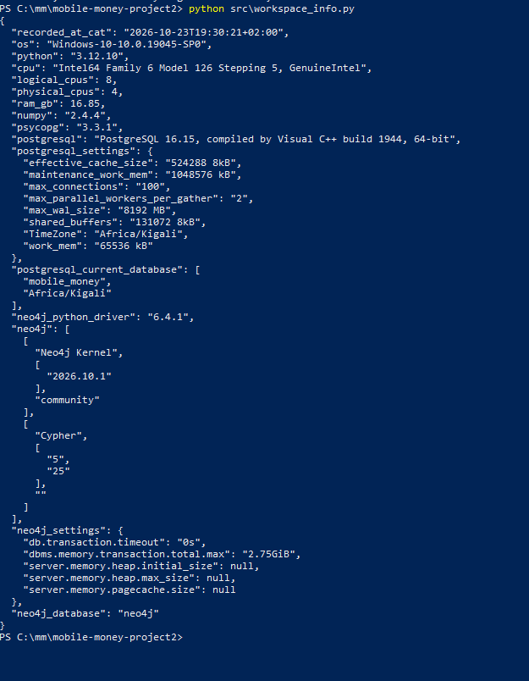
Workspace profile produced by src/workspace_info.py

1.1.2 PostgreSQL connection information and time-zone status
& "C:\Program Files\PostgreSQL\16\bin\psql.exe" -U postgres -d mobile_money -c "\conninfo" -c "SHOW timezone;"
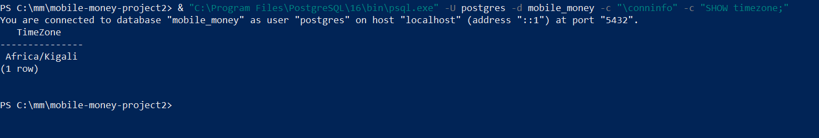
PostgreSQL connection info and time zone (Africa/Kigali)

1.1.3 Neo4j Browser
Neo4j Browser is available at http://localhost:7474/browser/.
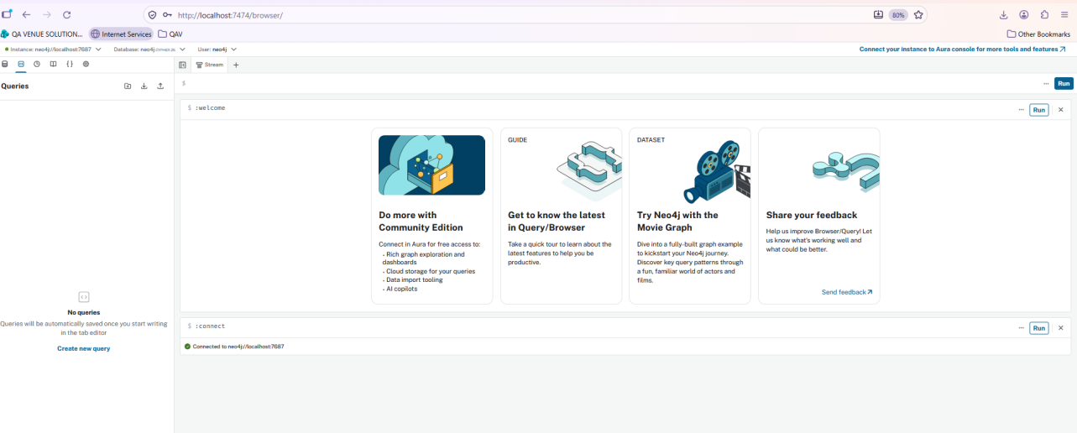
Neo4j Browser running locally

1.2 Data capture with capture.py

1.2.0.1 Ten records per stream.
python src\capture.py --preview
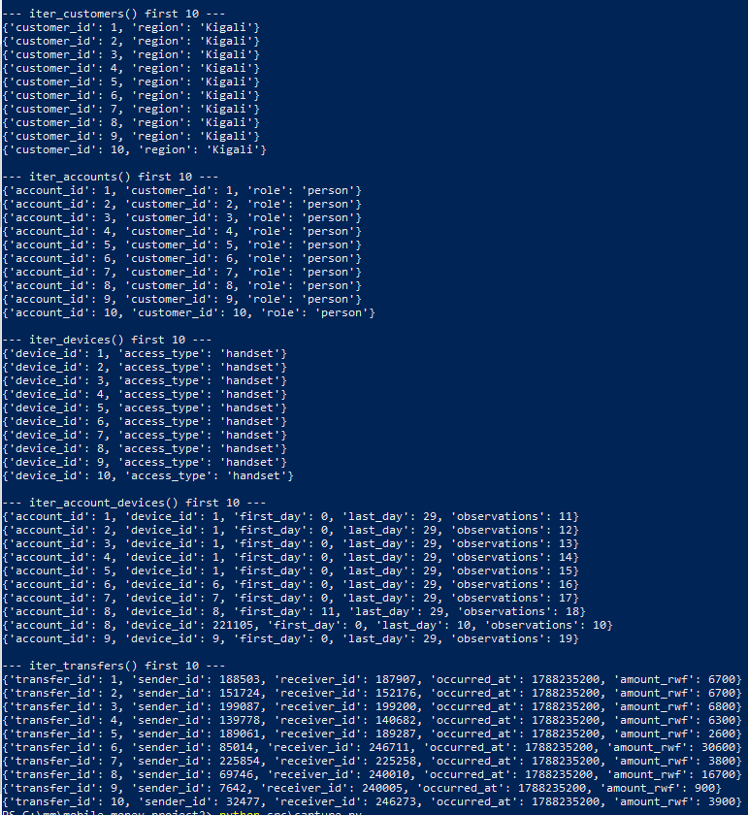
Preview of ten records per stream

1.2.0.2 Full capture.
python src\capture.py
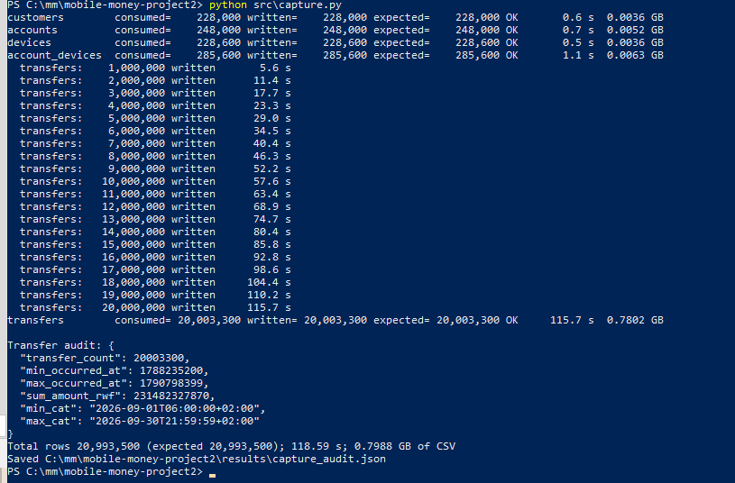
Full capture run
Capture summary per stream
Stream | Consumed | Written | Expected | Seconds | CSV GB
customers | 228,000 | 228,000 | 228,000 | 0.6 | 0.0036
accounts | 248,000 | 248,000 | 248,000 | 0.7 | 0.0052
devices | 228,600 | 228,600 | 228,600 | 0.5 | 0.0036
account_devices | 285,600 | 285,600 | 285,600 | 1.1 | 0.0063
transfers | 20,003,300 | 20,003,300 | 20,003,300 | 115.7 | 0.7802
Total | 20,993,500 | 20,993,500 | 20,993,500 | 118.59 | 0.7988
Transfer audit
audit_count | 20,003,300
min_occurred_at | 1788235200 (2026-09-01T06:00:00+02:00)
max_occurred_at | 1790798399 (2026-09-30T21:59:59+02:00)
sum amount_rwf | 231,482,327,870 RWF

2 Build PostgreSQL

2.1 Tables and constraints
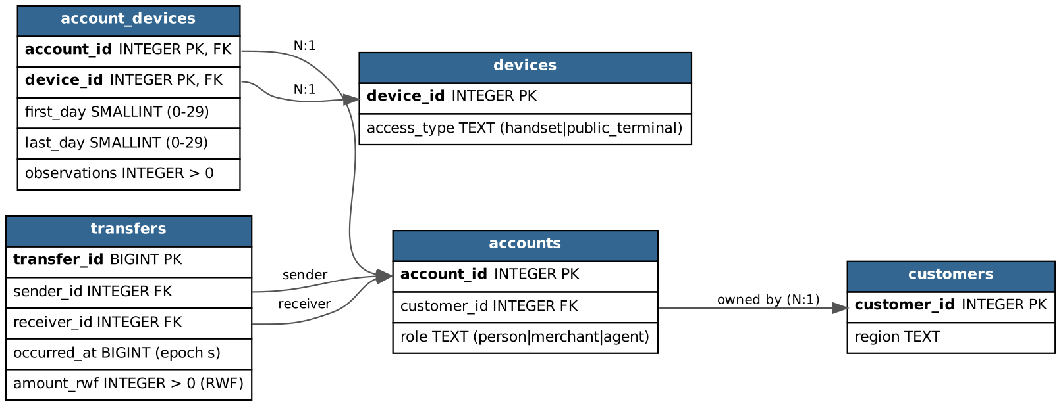
Relational schema (PK bold, FK arrows)
Field definitions
Field | Meaning and unit
customer_id / account_id / device_id | Integer entity identifiers (primary keys)
region | Owner region: Kigali, Northern, Southern, Eastern, Western
role | Wallet role: person, merchant or agent
access_type | handset or public_terminal
first_day, last_day | Inclusive observation day numbers, 0 = 1 Sep 2026 CAT … 29 = 30 Sep; CHECK $0≤\text{first}≤\text{last}≤29$
observations | Count of observations of that account on that device within the interval; CHECK $>0$
transfer_id | BIGINT event identifier, one row per payment
sender_id, receiver_id | Paying and receiving wallets (both FK to accounts)
occurred_at | BIGINT Unix epoch seconds (UTC instant; displayed in Africa/Kigali, UTC+02:00)
amount_rwf | INTEGER whole Rwandan francs; CHECK $>0$. A transfer value, not a balance or fee
All columns are NOT NULL. Primary keys: each entity/event ID, and (account_id, device_id) for account_devices. Foreign keys:
- accounts.customer_id $→$ customers;
- account_devices.account_id $→$ accounts;
- account_devices.device_id $→$ devices;
- transfers.sender_id and transfers.receiver_id $→$ accounts.
Definitions: sql/01_schema.sql and sql/03_constraints_indexes.sql.
& "C:\Program Files\PostgreSQL\16\bin\psql.exe" -U postgres -d mobile_money -f sql\01_schema.sql
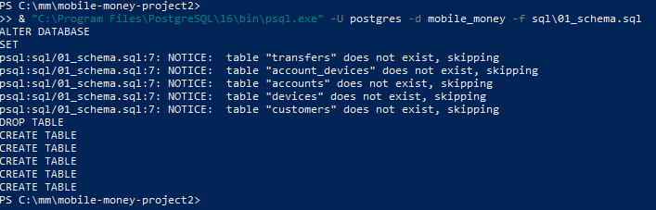
Creating the schema (01_schema.sql)

2.2 Bulk load and checks
Loading with \copy (parents first) took 46.8 s in total, of which transfers took 46.1 s. Keys, foreign keys, checks, the five indexes and VACUUM ANALYZE took a further 310.7 s and were timed separately. The largest steps were validating the transfers foreign keys (122.1 s) and building the receiver (110.9 s) and sender (47.1 s) indexes.
& "C:\Program Files\PostgreSQL\16\bin\psql.exe" -U postgres -d mobile_money -f sql\02_load.psql
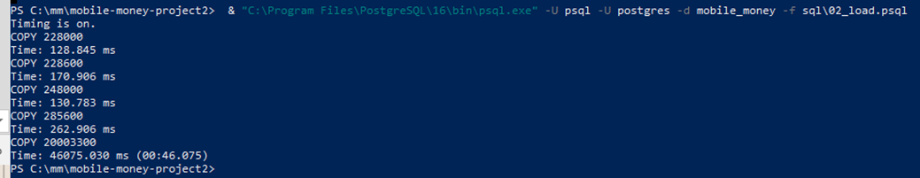
Bulk load with \copy (02_load.psql)
& "C:\Program Files\PostgreSQL\16\bin\psql.exe" -U postgres -d mobile_money -f sql\03_constraints_indexes.sql
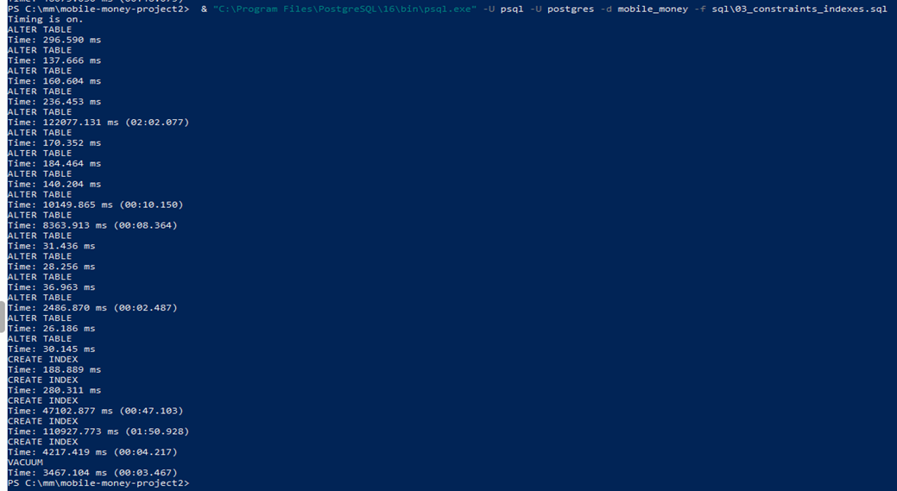
Keys, constraints and indexes (03_constraints_indexes.sql)
& "C:\Program Files\PostgreSQL\16\bin\psql.exe" -U postgres -d mobile_money -f sql\04_checks.sql
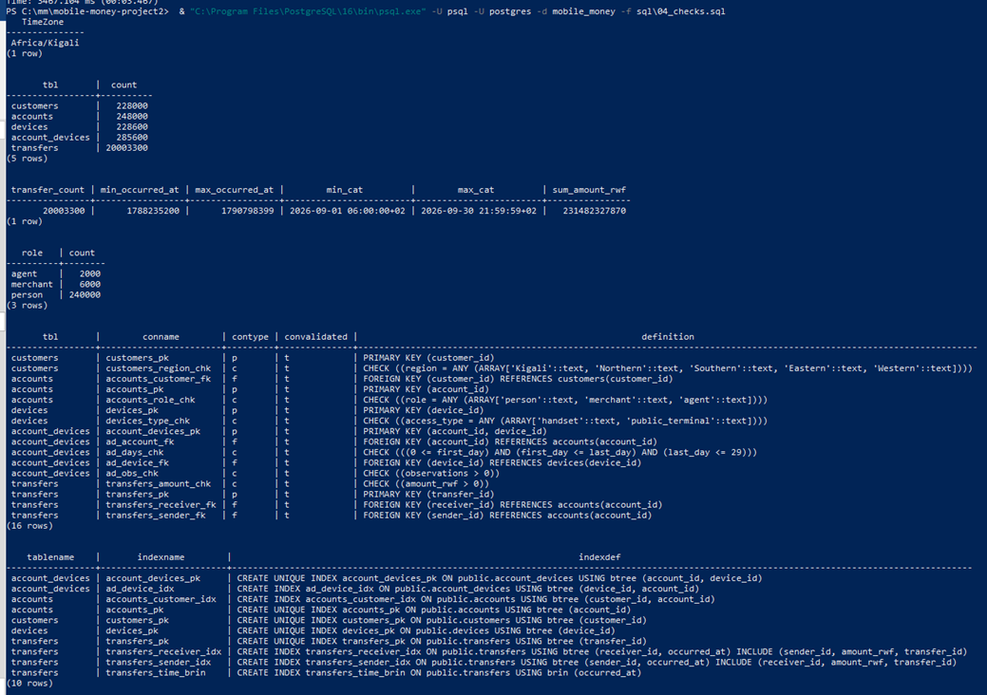
Post-load checks (04_checks.sql)
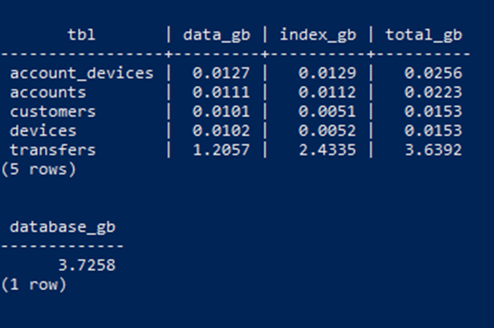
Table and database sizes
PostgreSQL load verification
Check | Result | Expected
Row counts | 228,000 / 248,000 / 228,600 / 285,600 / 20,003,300 | capture.py counts
Audit totals | 20,003,300; 1788235200–1790798399; 231,482,327,870 RWF | identical
Roles | person 240,000; merchant 6,000; agent 2,000 | same
Constraints | 16 constraints, all validated | –
Sizes ($1 \text{GB}={10}^{9}$ B) | transfers data 1.2057 GB + indexes 2.4335 GB; database 3.7258 GB | –

3 Build Neo4j

3.1 Mapping the same facts
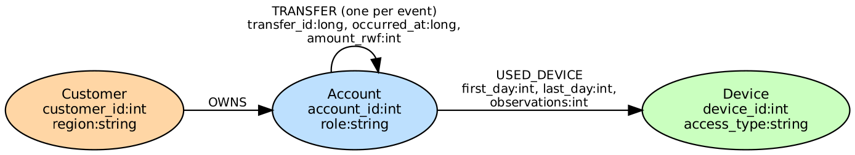
Graph schema
Mapping of relational fields to graph elements
Source field | Graph element
customers.customer_id, region | (:Customer {customer_id:int, region:string})
accounts.account_id, role | (:Account {account_id:int, role:string})
accounts.customer_id | (:Customer)-[:OWNS]->(:Account) via owns.csv (column ignored in Account node file)
devices.device_id, access_type | (:Device {device_id:int, access_type:string})
account_devices.* | (:Account)-[:USED_DEVICE {first_day, last_day, observations}]->(:Device)
transfers.* | (:Account)-[:TRANSFER {transfer_id:long, occurred_at:long, amount_rwf:int}]->(:Account), one per event

3.2 Import
prepare_import.py writes temporary copies with typed headers (data bytes streamed, sources unchanged) and derives owns.csv in (customer_id, account_id) order. Headers:
customer_id:ID(Customer),region:string
account_id:ID(Account),:IGNORE,role:string
device_id:ID(Device),access_type:string
:START_ID(Customer),:END_ID(Account)
:START_ID(Account),:END_ID(Device),first_day:int,last_day:int,observations:int
transfer_id:long,:START_ID(Account),:END_ID(Account),occurred_at:long,amount_rwf:int
neo4j-admin database import full neo4j --overwrite-destination=true --id-type=integer
--nodes=Customer=customers.csv --nodes=Account=accounts.csv --nodes=Device=devices.csv
--relationships=OWNS=owns.csv --relationships=USED_DEVICE=used_device.csv
--relationships=TRANSFER=transfers.csv
On our machine the offline import took 1 min 49.7 s (152.8 s including stopping and restarting the service). Creating the three unique constraints and the TRANSFER.occurred_at index took about 96.5 s, almost all of it waiting for the indexes to come online. The store uses 2.0494 GB and the transaction log 0.0000 GB, because an offline import writes the store files directly and does not go through transactions.
"store GB: {0:N4}" -f ((Get-ChildItem C:\neo4j\data\databases\neo4j -Recurse | Measure-Object Length -Sum).Sum / 1e9)
Neo4j store size
"tx-log GB: {0:N4}" -f ((Get-ChildItem C:\neo4j\data\transactions\neo4j -Recurse | Measure-Object Length -Sum).Sum / 1e9)
Neo4j transaction-log size

3.2.1 Import completion summary
python src\prepare_import.py
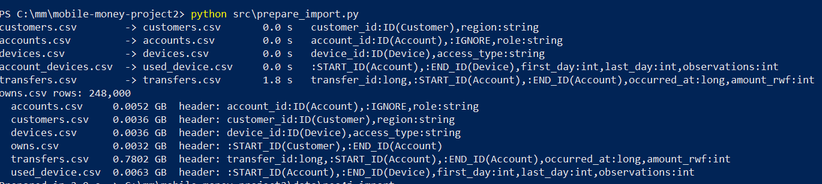
Preparing typed import files
.\cypher\01_import.ps1
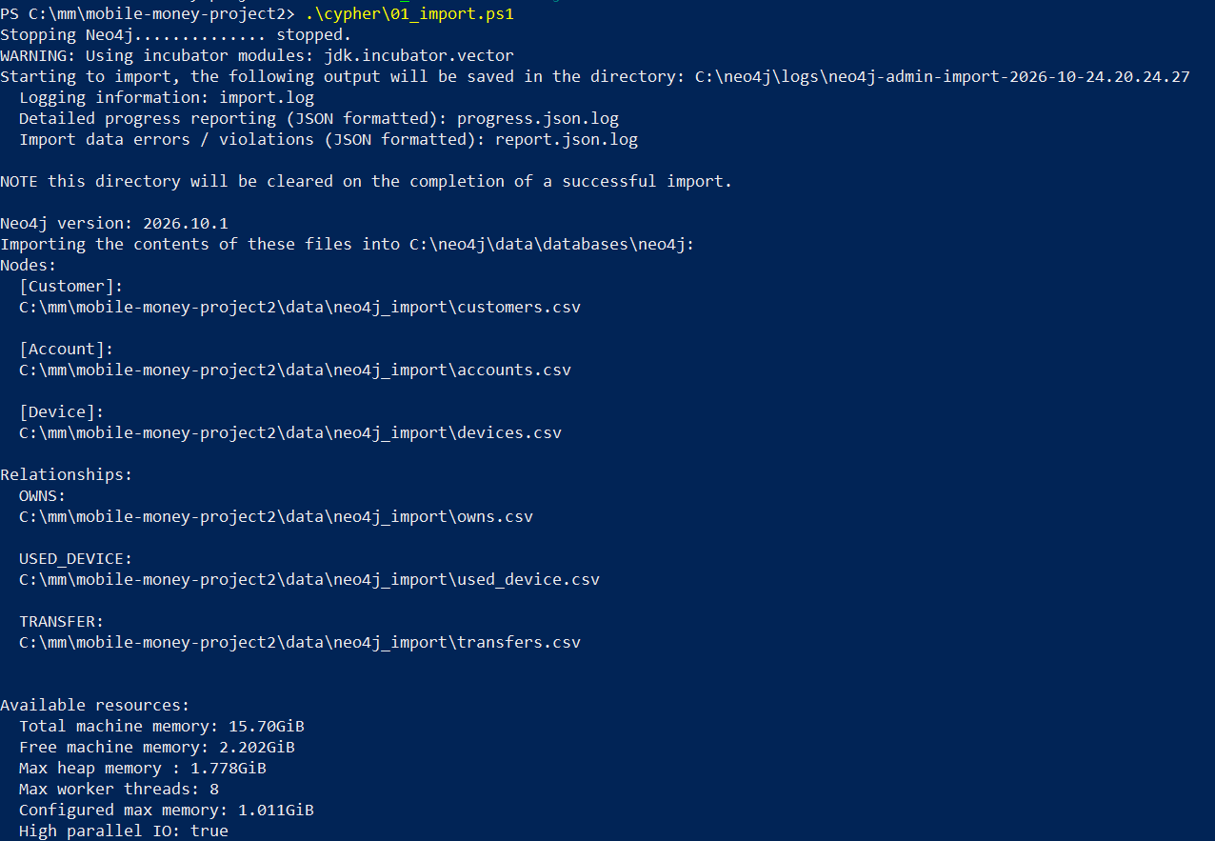
Running the offline import
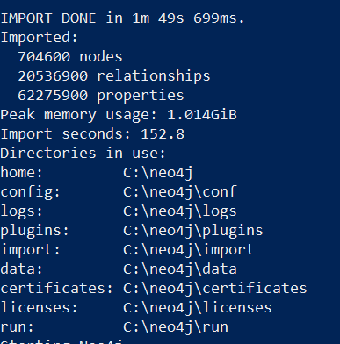
Import completion summary

3.2.2 Constraints and indexes (all ONLINE)
& $cs -u neo4j -p <password> -f cypher\02_constraints_indexes.cypher
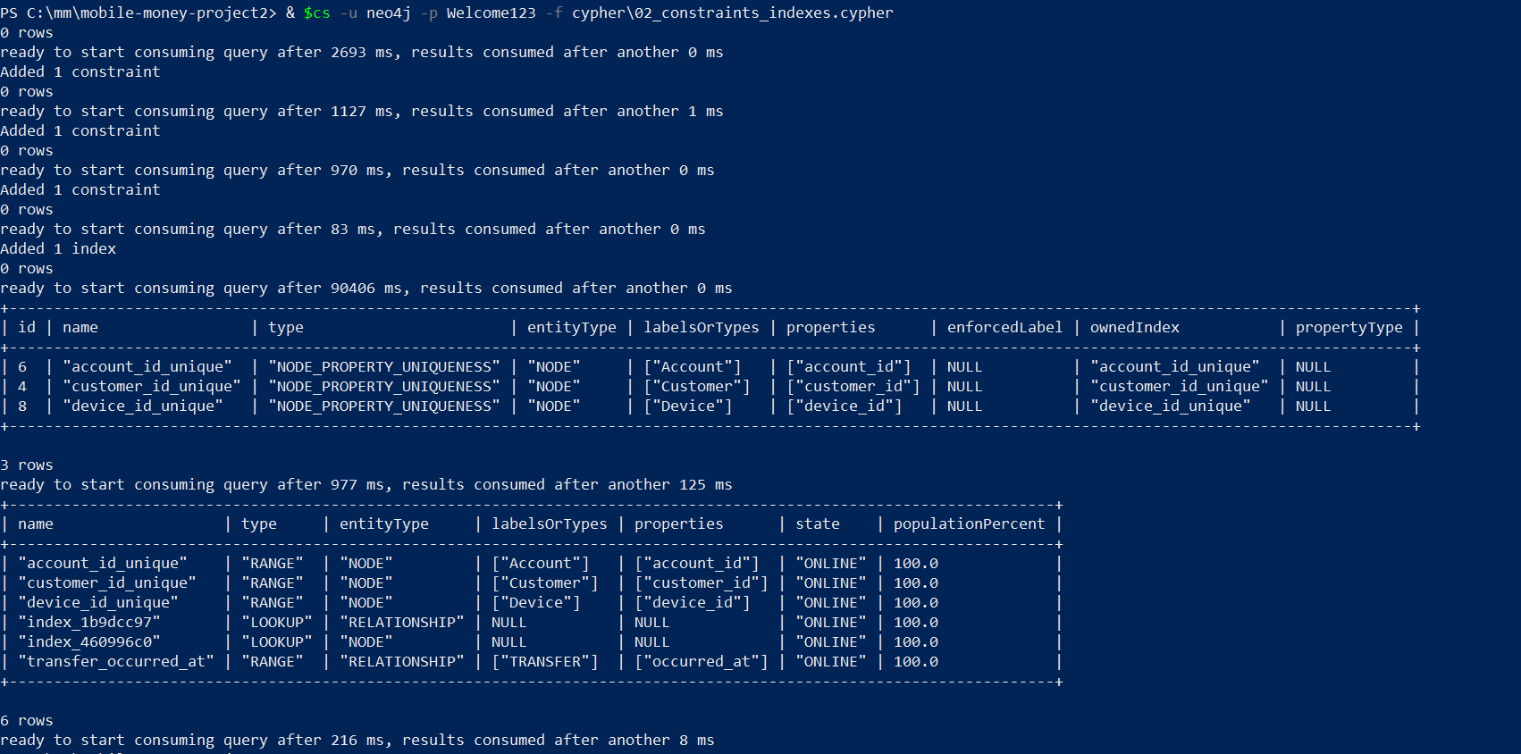
SHOW CONSTRAINTS / SHOW INDEXES – all ONLINE

3.2.3 Graph checks (03_checks.cypher)
& $cs -u neo4j -p <password> -f cypher\03_checks.cypher
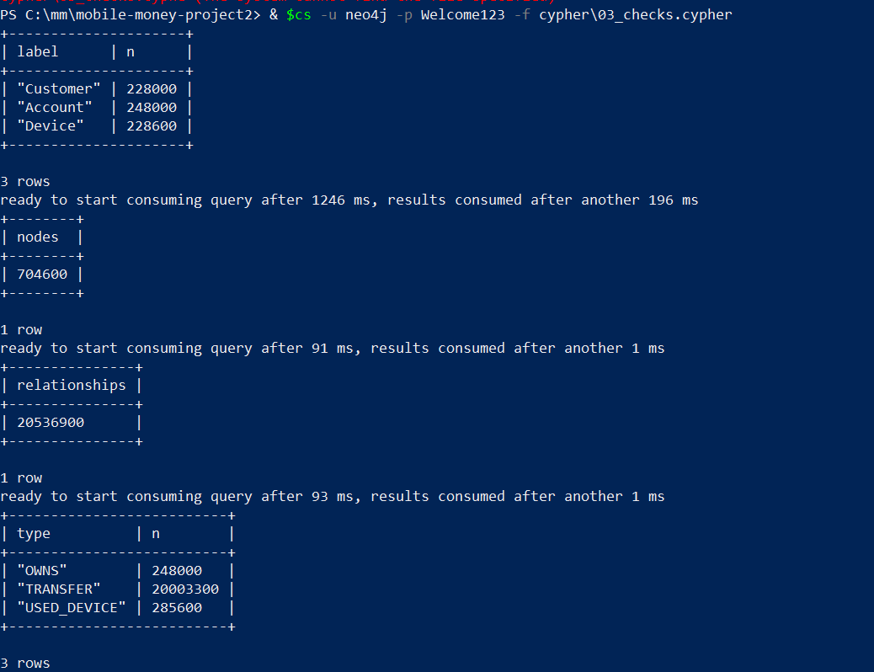
Node and relationship counts
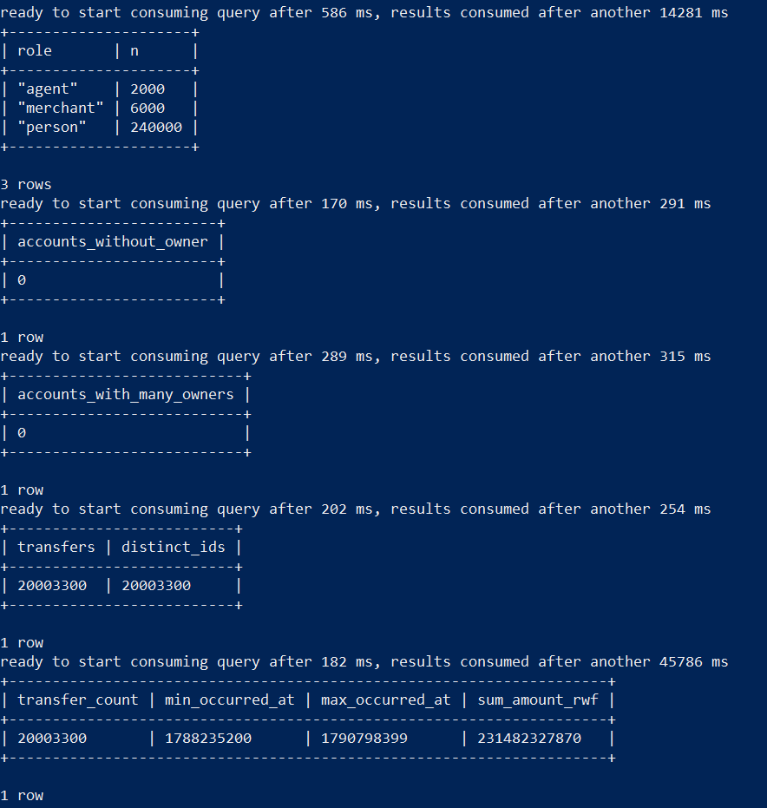
Roles, ownership and audit checks
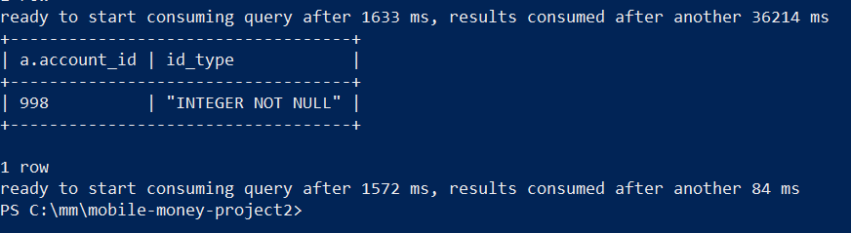
Identifier type check
Neo4j load verification
Check | Expected | Neo4j result
Customer / Account / Device nodes | 228,000 / 248,000 / 228,600 | 228,000 / 248,000 / 228,600
Total nodes | 704,600 | 704,600
OWNS / USED_DEVICE / TRANSFER | 248,000 / 285,600 / 20,003,300 | 248,000 / 285,600 / 20,003,300
Total relationships | 20,536,900 | 20,536,900
Roles | person 240,000, merchant 6,000, agent 2,000 | agent 2,000, merchant 6,000, person 240,000
Accounts without / with $>1$ owner | 0 / 0 | 0 / 0
Distinct transfer_id | 20,003,300 | 20,003,300
Audit totals | 1788235200, 1790798399, 231,482,327,870 | 1788235200, 1790798399, 231,482,327,870

3.2.4 Cleaning temporary import files
python src\prepare_import.py --clean
Removing temporary import copies
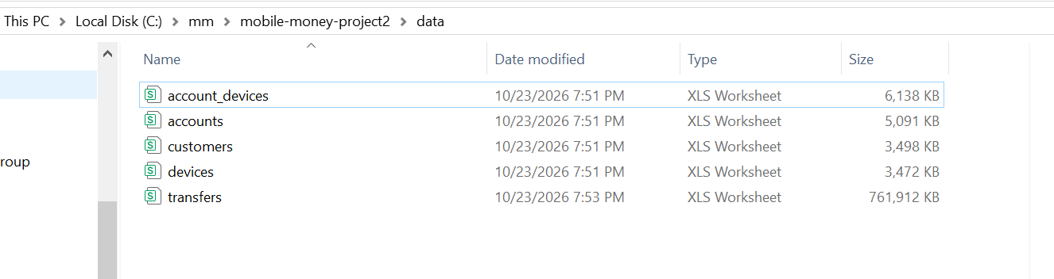
Source CSV files remain unchanged

3.3 One account in both models
Account 998 (person) is owned by Customer 998 (Kigali), observed on handset 998 (days 0–29, 39 observations) and its first outgoing transfer is #113540 to merchant 240004 on 1 Sep 08:43:29 CAT for 2,100 RWF (src/trace_account.py). In SQL each step is a JOIN on a foreign key (accounts.customer_id, account_devices.account_id/device_id, transfers.sender_id); in Neo4j the same foreign keys are stored as relationships (OWNS, USED_DEVICE, TRANSFER) that are followed directly from node to node. The account_devices table and the transfers table become relationships with properties.
Account 998 paid account 1111 nine separate times (and 63 seven times). Collapsing repeats into one edge would erase each transfer_id, its timestamp and amount, so Q1 counts, Q2 daily totals, the strict time order and 600 s gaps of Q5 and the amount rule of Q5/Q6 could no longer be evaluated.
python src\trace_account.py --account 998
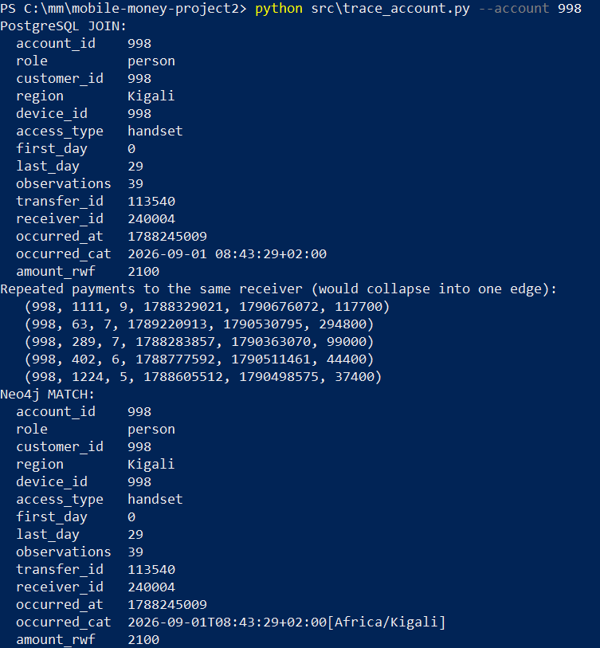
Account 998 traced through SQL joins and a Neo4j match

4 Routine Business Questions

4.1 Q1 – Account activity
python src\screens.py q1
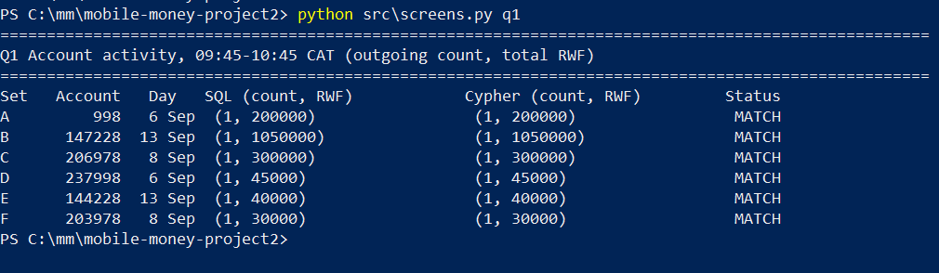
Q1 results, SQL versus Cypher
Q1 outgoing transfers, 09:45–10:45 CAT
Set | Account | Date | Outgoing count | Total RWF | SQL = reference
A | 998 | 6 Sep | 1 | 200,000 | MATCH
B | 147228 | 13 Sep | 1 | 1,050,000 | MATCH
C | 206978 | 8 Sep | 1 | 300,000 | MATCH
D | 237998 | 6 Sep | 1 | 45,000 | MATCH
E | 144228 | 13 Sep | 1 | 40,000 | MATCH
F | 203978 | 13 Sep | 1 | 30,000 | MATCH
The Q1 query counts outgoing transfers and sums their values between 09:45 and 10:45 Rwanda time on each set’s specified September 2026 date.
Outgoing value is not a balance. It ignores incoming transfers, the opening balance, cash-in and cash-out at agents, fees and reversals, none of which are in these records.

4.2 Q2 – Daily activity
python src\screens.py q2
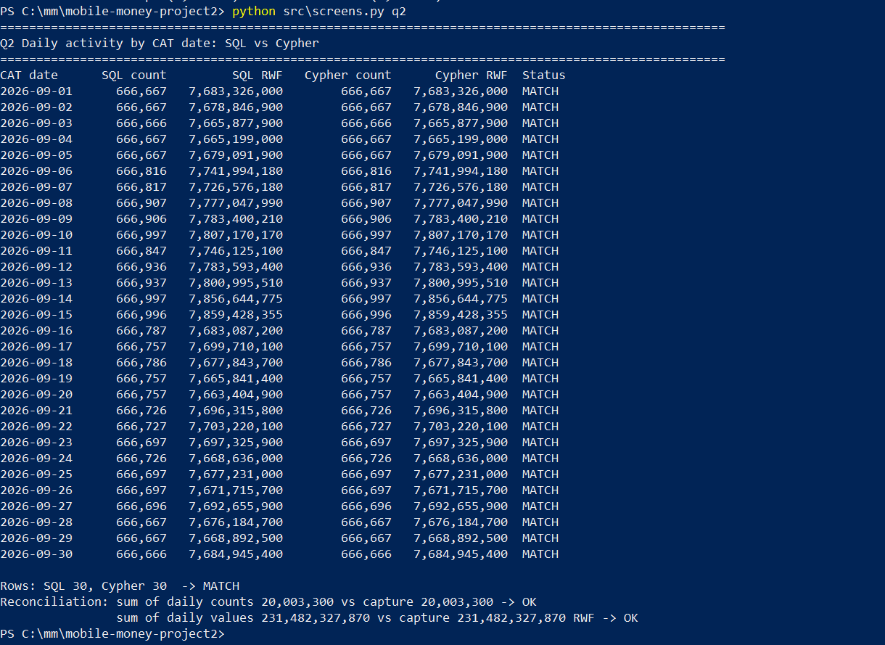
Q2 daily totals, SQL versus Cypher, with reconciliation

4.2.0.1 Comparing using Neo4j.
MATCH ()-[t:TRANSFER]->()
WITH date(datetime({epochSeconds: t.occurred_at, timezone: 'Africa/Kigali'})) AS cat_date,
t.amount_rwf AS amount
RETURN cat_date, count(*) AS transfers, sum(amount) AS total_rwf
ORDER BY cat_date
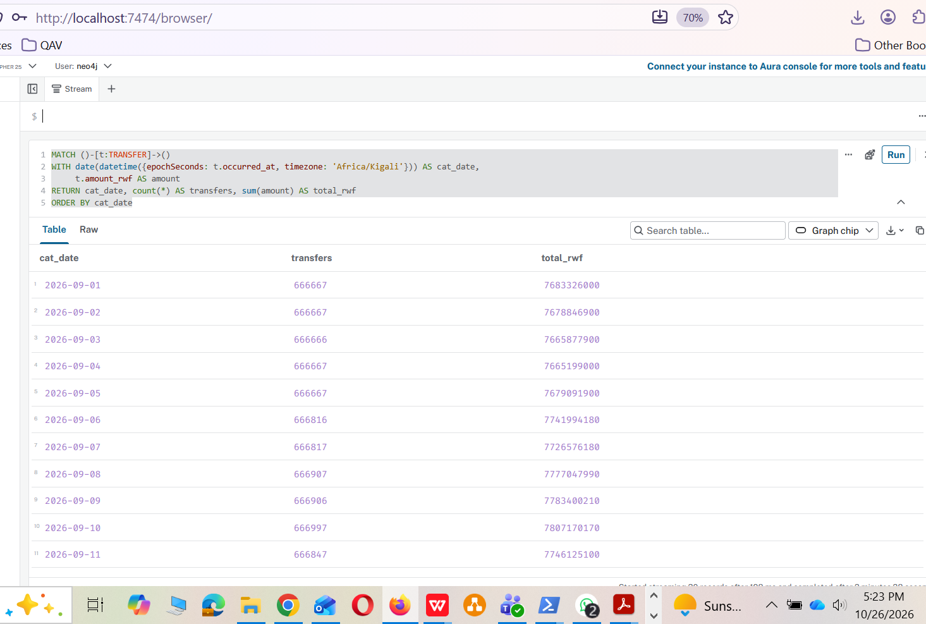
Q2 in Neo4j Browser

4.2.0.2 Chart generation.
python src\plots.py
# charts written to C:\mm\mobile-money-project2\results\charts
Generating the charts
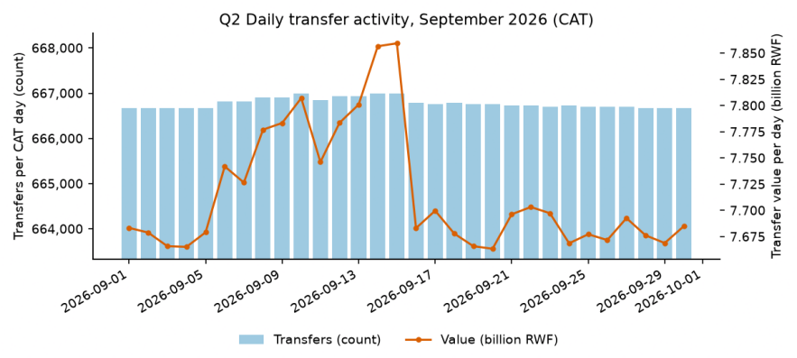
Daily transfer count and value (CAT days)
The 30 days sum to 20,003,300 transfers and 231,482,327,870 RWF, which reconciles exactly with the capture audit. The daily count is almost flat at about 666,667, but 6 to 15 September carry about 150 to 330 extra transfers per day and up to 190 million RWF more value (7.86 billion RWF on 14 and 15 September against about 7.67 to 7.70 billion on other days). These extra high-value transfers are the payments examined in Section 5. Transfer value is not provider revenue: revenue comes from fees, and the same money can be counted several times as it moves between wallets.

4.3 Q3 – Shared devices
python src\screens.py q3
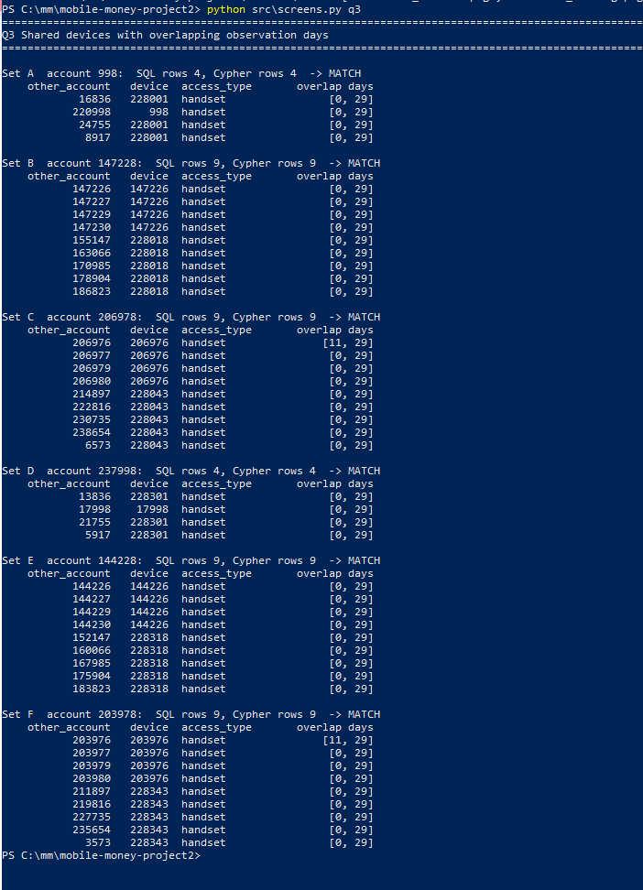
Q3 shared devices with overlapping observation days
Q3 accounts sharing a device with the review account (all handsets). Format: other_account@device [overlap days]
Set | Account | Rows | Other account @ device [overlap days]
A | 998 | 4 | 16836@228001 [0,29]; 220998@998 [0,29]; 24755@228001 [0,29]; 8917@228001 [0,29]
B | 147228 | 9 | 147226@147226 [0,29]; 147227@147226 [0,29]; 147229@147226 [0,29]; 147230@147226 [0,29]; 155147@228018 [0,29]; 163066@228018 [0,29]; 170985@228018 [0,29]; 178904@228018 [0,29]; 186823@228018 [0,29]
C | 206978 | 9 | 206976@206976 [11,29]; 206977@206976 [0,29]; 206979@206976 [0,29]; 206980@206976 [0,29]; 214897@228043 [0,29]; 222816@228043 [0,29]; 230735@228043 [0,29]; 238654@228043 [0,29]; 6573@228043 [0,29]
D | 237998 | 4 | 13836@228301 [0,29]; 17998@17998 [0,29]; 21755@228301 [0,29]; 5917@228301 [0,29]
E | 144228 | 9 | 144226@144226 [0,29]; 144227@144226 [0,29]; 144229@144226 [0,29]; 144230@144226 [0,29]; 152147@228318 [0,29]; 160066@228318 [0,29]; 167985@228318 [0,29]; 175904@228318 [0,29]; 183823@228318 [0,29]
F | 203978 | 9 | 203976@203976 [11,29]; 203977@203976 [0,29]; 203979@203976 [0,29]; 203980@203976 [0,29]; 211897@228343 [0,29]; 219816@228343 [0,29]; 227735@228343 [0,29]; 235654@228343 [0,29]; 3573@228343 [0,29]
Interpretation
Legitimate sharing. In set A, accounts 998 and 220998 share handset 998 for days 0 to 29 because both wallets belong to customer 998, so the second wallet simply runs on the owner’s phone. In set B, handset 147226 is a household phone that is also used by accounts 147226 to 147230.
What an overlap means. An overlap only means that both accounts were observed on the device at some point during the overlapping days, not at the same moment. Intervals $\left[2,7\right]$ and $\left[5,11\right]$ overlap on $\left[5,7\right]$ even if one person used the phone in the morning and another at night.

5 Connected Accounts

5.1 Q4 – Ownership and device network
python src\screens.py q4
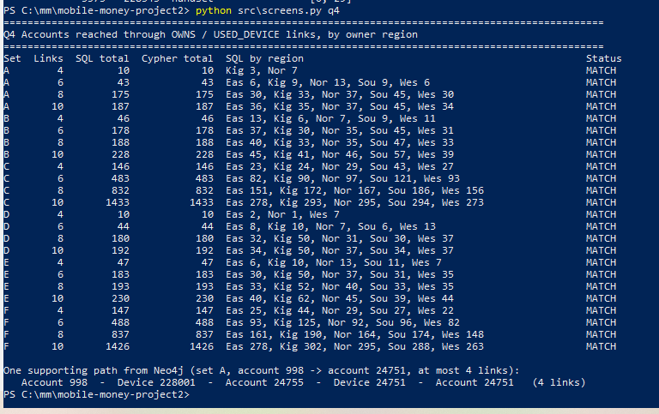
Q4 accounts reached through OWNS / USED_DEVICE links, by owner region
Q4 accounts reached by number of links, with owner region
Set | Links | Accounts | By owner region
Set | Links | Accounts | By owner region
A | 4 | 10 | Kigali 3, Northern 7
A | 6 | 43 | Eastern 6, Kigali 9, Northern 13, Southern 9, Western 6
A | 8 | 175 | Eastern 30, Kigali 33, Northern 37, Southern 45, Western 30
A | 10 | 187 | Eastern 36, Kigali 35, Northern 37, Southern 45, Western 34
B | 4 | 46 | Eastern 13, Kigali 6, Northern 7, Southern 9, Western 11
B | 6 | 178 | Eastern 37, Kigali 30, Northern 35, Southern 45, Western 31
B | 8 | 188 | Eastern 40, Kigali 33, Northern 35, Southern 47, Western 33
B | 10 | 228 | Eastern 45, Kigali 41, Northern 46, Southern 57, Western 39
C | 4 | 146 | Eastern 23, Kigali 24, Northern 29, Southern 43, Western 27
C | 6 | 483 | Eastern 82, Kigali 90, Northern 97, Southern 121, Western 93
C | 8 | 832 | Eastern 151, Kigali 172, Northern 167, Southern 186, Western 156
C | 10 | 1,433 | Eastern 278, Kigali 293, Northern 295, Southern 294, Western 273
D | 4 | 10 | Eastern 2, Northern 1, Western 7
D | 6 | 44 | Eastern 8, Kigali 10, Northern 7, Southern 6, Western 13
D | 8 | 180 | Eastern 32, Kigali 50, Northern 31, Southern 30, Western 37
D | 10 | 192 | Eastern 34, Kigali 50, Northern 37, Southern 34, Western 37
E | 4 | 47 | Eastern 6, Kigali 10, Northern 13, Southern 11, Western 7
E | 6 | 183 | Eastern 30, Kigali 50, Northern 37, Southern 31, Western 35
E | 8 | 193 | Eastern 33, Kigali 52, Northern 40, Southern 33, Western 35
E | 10 | 230 | Eastern 40, Kigali 62, Northern 45, Southern 39, Western 44
F | 4 | 147 | Eastern 25, Kigali 44, Northern 29, Southern 27, Western 22
F | 6 | 488 | Eastern 93, Kigali 125, Northern 92, Southern 96, Western 82
F | 8 | 837 | Eastern 161, Kigali 190, Northern 164, Southern 174, Western 148
F | 10 | 1,426 | Eastern 278, Kigali 302, Northern 295, Southern 288, Western 263
MATCH (a:Account {account_id:998}), (b:Account {account_id:24751})
MATCH p = shortestPath((a)-[:OWNS|USED_DEVICE*1..4]-(b))
RETURN p
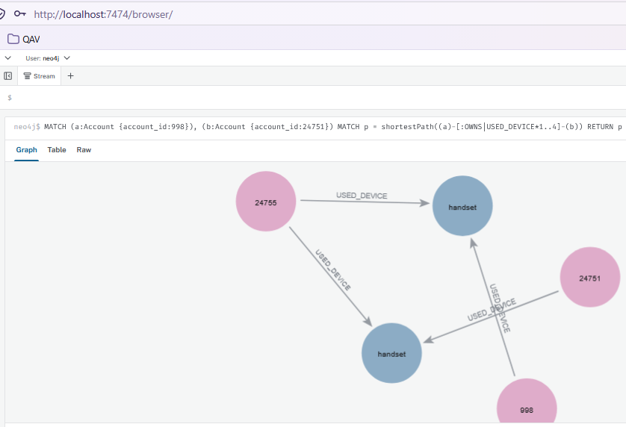
Supporting ownership/device path for set A (998 to 24751) in Neo4j Browser
Generating the depth chart
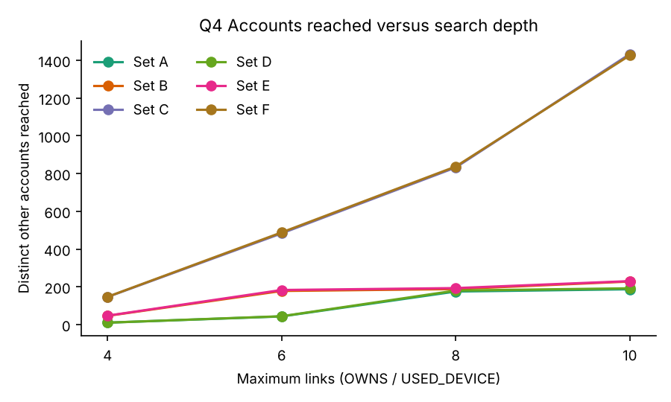
Accounts reached versus depth
- The group predicted that Set F would grow sharply while Sets A, B, C, D and E would quickly plateau.
- The data showed that only A, B, D and E levelled off, while both C and F grew roughly threefold at each step due to shared household connections.
- Deeper links (depth 8–10) provide weak associations because they rely on highly indirect, multi-person phone sharing rather than direct connections.

5.2 Q5 – Rapid onward payments
python src\screens.py q5
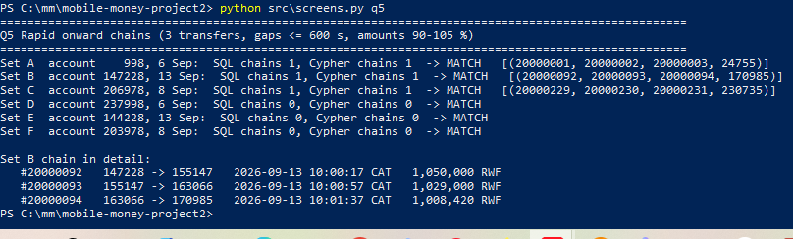
Q5 rapid onward chains (3 transfers, gaps $≤$ 600 s, amounts 90–105 %)
Q5 chains found per set
Set | Chains | (t1, t2, t3, final receiver)
A | 1 | (20000001, 20000002, 20000003, 24755)
B | 1 | (20000092, 20000093, 20000094, 170985)
C | 1 | (20000229, 20000230, 20000231, 230735)
D | 0 | none
E | 0 | none
F | 0 | none
MATCH p = (:Account {account_id:147228})-[:TRANSFER {transfer_id:20000092}]->()
-[:TRANSFER {transfer_id:20000093}]->()-[:TRANSFER {transfer_id:20000094}]->()
RETURN p
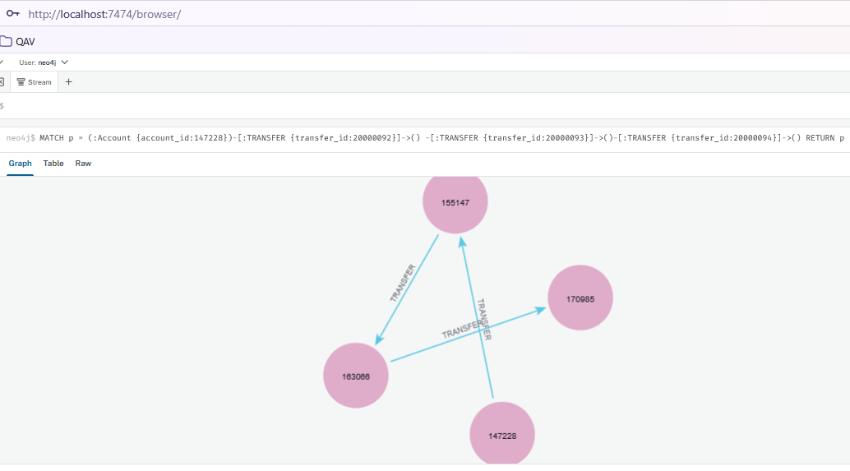
Set B chain in Neo4j Browser
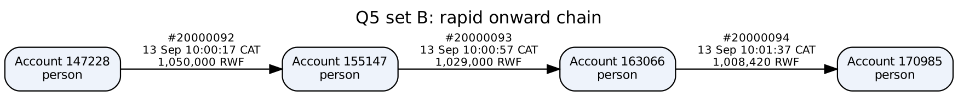
Set B chain
Set B: #20000092 147228$→$155147 at 13 Sep 10:00:17 CAT for 1,050,000 RWF; #20000093 155147$→$163066 at 10:00:57 for 1,029,000 (98 %); #20000094 163066$→$170985 at 10:01:37 for 1,008,420 (98 %).
The chain does not prove that the same money moved. Wallet balances are interchangeable, each intermediate account may already have held enough money, and similar amounts 40 seconds apart can be coincidence or an ordinary business pattern, such as paying a supplier right after being paid. Without balances, these records cannot trace specific funds.

5.3 Q6 – Circular payments
python src\screens.py q6
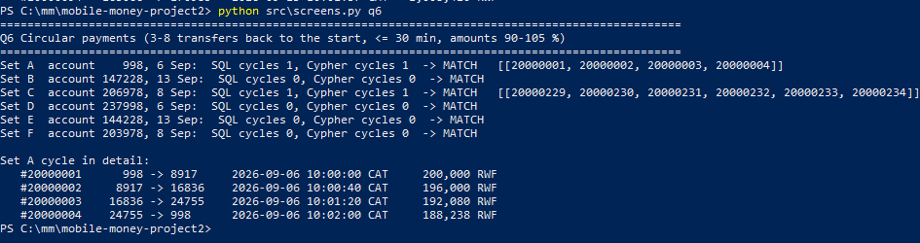
Q6 circular payments (3–8 transfers back to the start, $≤$ 30 min, amounts 90–105 %)
Q6 cycles found per set
Set | Cycles | Transfer-ID sequence
A | 1 | [20000001, 20000002, 20000003, 20000004] (length 4)
B | 0 | none
C | 1 | [20000229, 20000230, 20000231, 20000232, 20000233, 20000234] (length 6)
D | 0 | none
E | 0 | none
F | 0 | none
MATCH p = (a:Account {account_id:998})-[:TRANSFER {transfer_id:20000001}]->()
-[:TRANSFER {transfer_id:20000002}]->()-[:TRANSFER {transfer_id:20000003}]->()
-[:TRANSFER {transfer_id:20000004}]->(a)
RETURN p
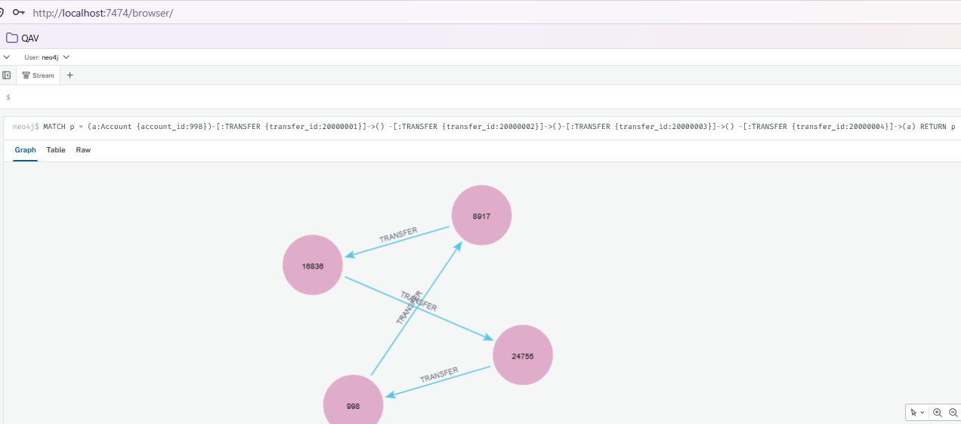
Set A cycle in Neo4j Browser
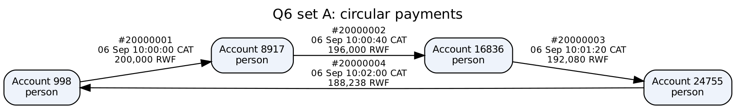
Set A cycle
- A: 998$→$8917$→$16836$→$24755$→$998 on 6 Sep between 10:00:00 and 10:02:00 CAT, 200,000 $→$ 196,000 $→$ 192,080 $→$ 188,238 RWF.
- C: a six-transfer cycle 206978$→$…$→$6573$→$206978 on 8 Sep 10:00:42–10:04:02, 300,000 falling 2 % per hop to 271,176 RWF.
Further evidence to request: wallet balances before and after the cycle, identity (KYC) records and any relationship between the account owners, the device and location that started each payment, the fees charged, any cash-out at agents afterwards, and the history of the same accounts in other months.

5.4 Q7 – Shortest transfer connection
python src\screens.py q7
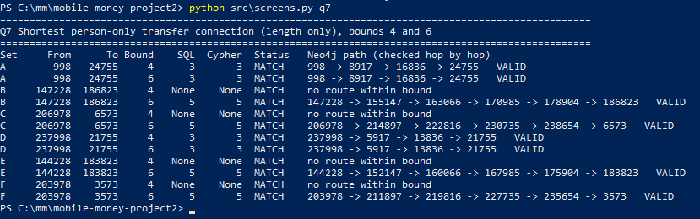
Q7 shortest person-only transfer connections (bounds 4 and 6)
Q7 shortest person-only transfer connection
Set | From | To | Bound 4 | Bound 6 |  | One supporting path (SQL) | Check
A | 998 | 24755 | 3 | 3 |  | 998 $→$ 8917 $→$ 16836 $→$ 24755 | valid
B | 147228 | 186823 | none $≤$4 | 5 |  | 147228 $→$ 147793 $→$ 147197 $→$ 148101 $→$ 178904 $→$ 186823 | valid
C | 206978 | 6573 | none $≤$4 | 5 |  | 206978 $→$ 214897 $→$ 222816 $→$ 230735 $→$ 238654 $→$ 6573 | valid
D | 237998 | 21755 | 3 | 3 |  | 237998 $→$ 5917 $→$ 13836 $→$ 21755 | valid
E | 144228 | 183823 | none $≤$4 | 5 |  | 144228 $→$ 152147 $→$ 160066 $→$ 167985 $→$ 175904 $→$ 183823 | valid
F | 203978 | 3573 | none $≤$4 | 5 |  | 203978 $→$ 211897 $→$ 219816 $→$ 227735 $→$ 235654 $→$ 3573 | valid
MATCH (a:Account {account_id:147228}), (d:Account {account_id:186823})
MATCH p = shortestPath((a)-[:TRANSFER*1..6]->(d))
WHERE all(n IN nodes(p) WHERE n.role = 'person')
RETURN p
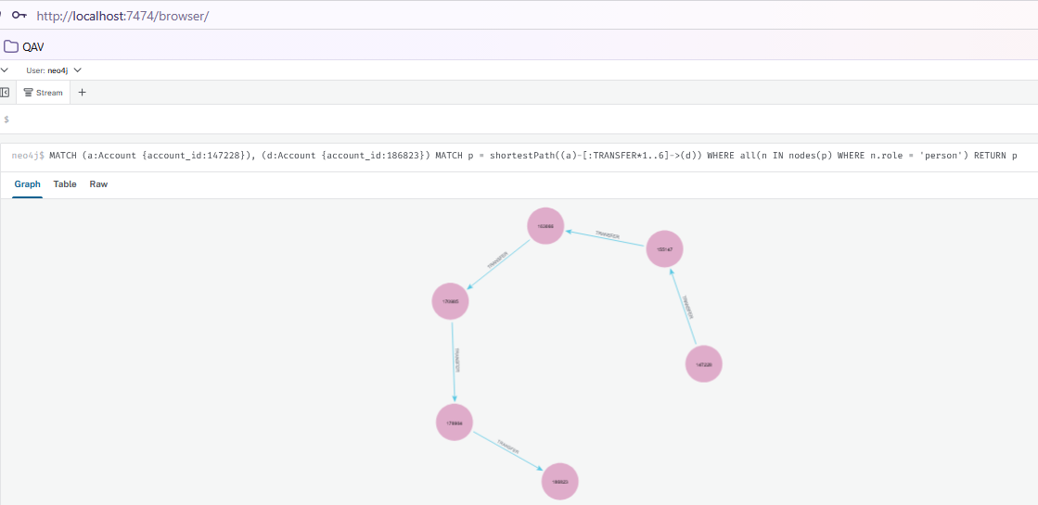
Set B shortest route in Neo4j Browser
One shortest person-only route for set B
Every path was checked hop by hop. B’s SQL path (147228$→$147793$→$147197$→$148101$→$178904$→$186823) differs from the scenario route but is equally short, illustrating that shortest paths are not unique.
For set B, Neo4j returned 147228, 155147, 163066, 170985, 178904, 186823 while SQL returned 147228, 147793, 147197, 148101, 178904, 186823. Both have five transfers and both passed the hop-by-hop check (stored transfer in the right direction, person accounts only, length equal to the minimum).
“No route within four transfers” only means there is no connection that short through person accounts. Longer routes, routes through merchants or agents, cash, or other providers are not excluded. A structural route also ignores time and amount, so its transfers can run backwards in time and need not carry the same money.

6 Correctness and Performance

6.1 Comparison program
compare.py calls run_pg and run_neo, normalises integers, dates and lists, sorts the rows and compares them exactly. Q7 lengths are compared separately from the validity of the supporting paths. On our machine all 61 PostgreSQL results and all 61 Neo4j results are identical to each other and to the independent pandas answers (reference_answers.py). The independent CSV checks (independent_checks.py) also pass: accounts 998 and 220998 overlap on device 998 for days $\left[0,29\right]$, and every rule for the Q5 chain and the Q6 cycle of set A is true.
python src\compare.py
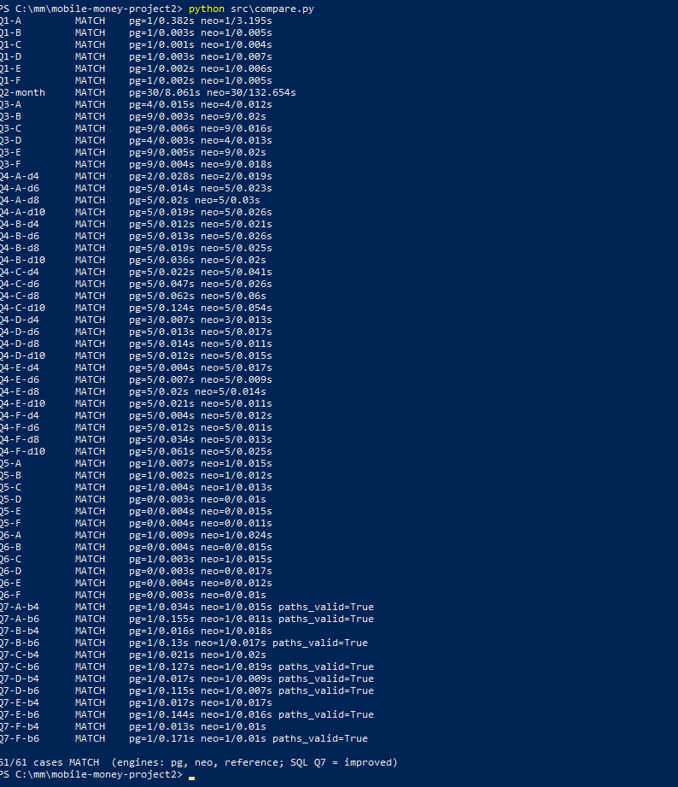
compare.py: 61/61 cases MATCH
python src\independent_checks.py
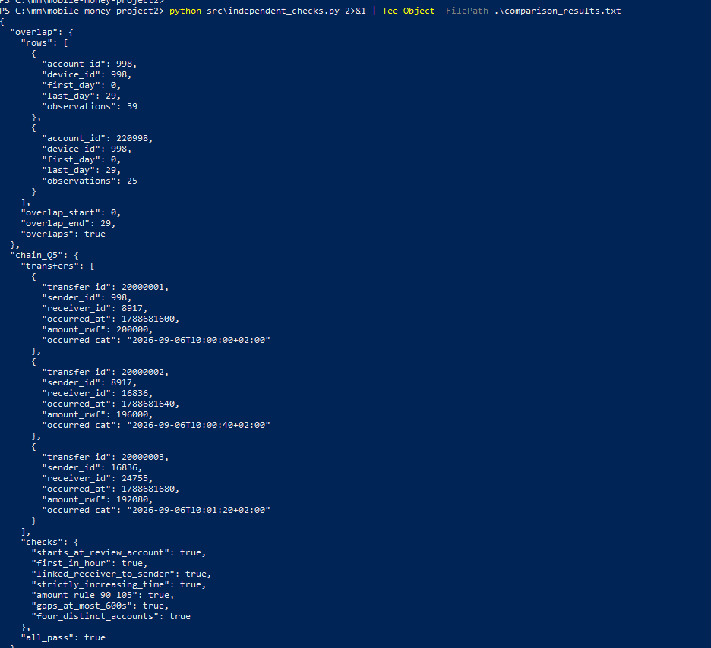
Independent CSV checks (overlap and Q5 chain)
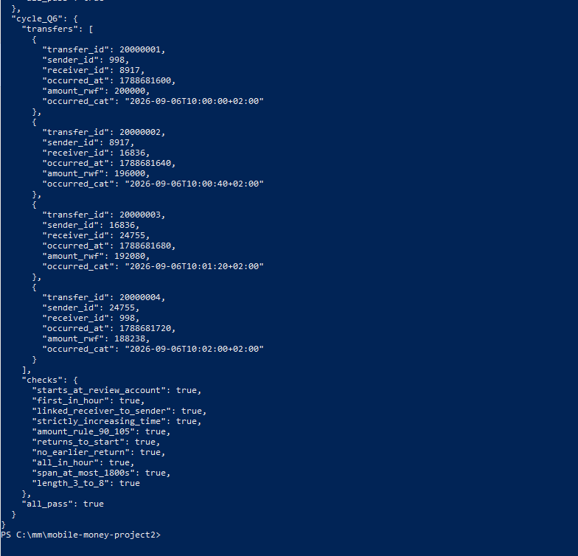
Independent CSV checks (Q6 cycle, all_pass = true)
Single-run timings from the comparison program
Query | PostgreSQL (s) | Neo4j (s) | Faster engine
Q1-A | 2.109 | 8.209 | PostgreSQL
Q2-month | 8.379 | 127.9 | PostgreSQL
Q3-A | 0.018 | 1.083 | PostgreSQL
Q4-A-d4 | 0.030 | 0.571 | PostgreSQL
Q7-A-b4 | 0.098 | 0.356 | PostgreSQL
Q7-A-b6 | 0.466 | 0.131 | Neo4j

Correctness across all cases
Question | Cases | PostgreSQL = reference | Neo4j = PostgreSQL
Q1 | 6 | 6 | 6
Q2 | 1 | 1 | 1
Q3 | 6 | 6 | 6
Q4 | 24 | 24 | 24
Q5 | 6 | 6 | 6
Q6 | 6 | 6 | 6
Q7 | 12 | 12 | 12
Total | 61 | 61 | 61
Insight
Our project passes all 61 comparison test cases across PostgreSQL (pg), Neo4j (neo) and the reference results. The independent checks also confirm that the transfer chain and cycle satisfy their validation rules.

6.2 Timing a fixed selection

6.2.0.1 First, stop Neo4j
so that the engines do not compete for memory:
& "C:\neo4j\bin\neo4j.bat" status
& "C:\neo4j\bin\neo4j.bat" stop
Stopping Neo4j

6.2.0.2 Benchmark runs.
python src\benchmark.py --engine pg --sql-q7 baseline # PostgreSQL timings
python src\explain_plans.py --engines pg # query-plan analysis
Stop-Service postgresql-x64-16 # stop PostgreSQL
python src\benchmark.py --engine neo # Neo4j timings
python src\explain_plans.py --engines neo # Neo4j execution plans
Start-Service postgresql-x64-16 # restart PostgreSQL
python src\benchmark.py --summarize # aggregation and reporting
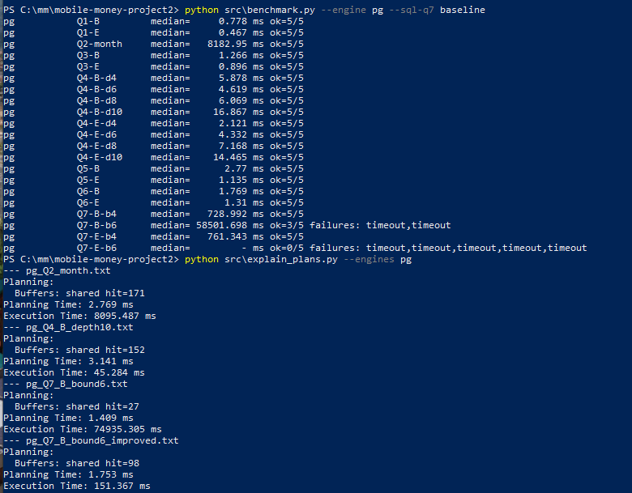
PostgreSQL benchmark and plans
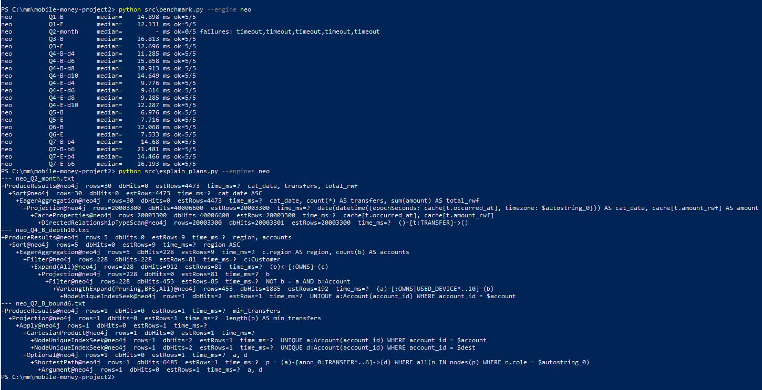
Neo4j benchmark and plans
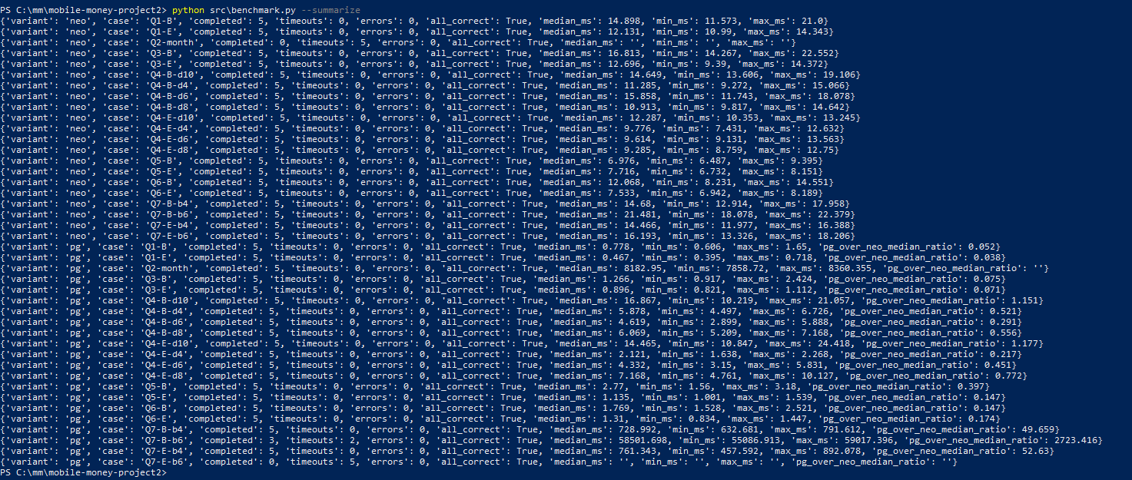
Benchmark summary
Median of 5 measured runs per case (ms), after 3 warm-ups; 60 s limit per run
Case | PG median | PG min | PG max | PG improved | Neo4j median | PG/Neo
Case | PG median | PG min | PG max | PG improved | Neo4j median | PG/Neo
Q1-B | 0.778 | 0.606 | 1.650 |  | 14.898 | 0.052
Q1-E | 0.467 | 0.395 | 0.718 |  | 12.131 | 0.038
Q2-month | 8,182.950 | 7,858.720 | 8,360.355 |  | timeout (0/5) | –
Q3-B | 1.266 | 0.917 | 2.424 |  | 16.813 | 0.075
Q3-E | 0.896 | 0.821 | 1.112 |  | 12.696 | 0.071
Q4-B-d4 | 5.878 | 4.497 | 6.726 |  | 11.285 | 0.521
Q4-B-d6 | 4.619 | 2.899 | 5.888 |  | 15.858 | 0.291
Q4-B-d8 | 6.069 | 5.209 | 7.168 |  | 10.913 | 0.556
Q4-B-d10 | 16.867 | 10.219 | 21.057 |  | 14.649 | 1.151
Q4-E-d4 | 2.121 | 1.638 | 2.268 |  | 9.776 | 0.217
Q4-E-d6 | 4.332 | 3.150 | 5.831 |  | 9.614 | 0.451
Q4-E-d8 | 7.168 | 4.761 | 10.127 |  | 9.285 | 0.772
Q4-E-d10 | 14.465 | 10.847 | 24.418 |  | 12.287 | 1.177
Q5-B | 2.770 | 1.560 | 3.180 |  | 6.976 | 0.397
Q5-E | 1.135 | 0.901 | 1.539 |  | 7.716 | 0.147
Q6-B | 1.769 | 1.528 | 2.521 |  | 12.068 | 0.147
Q6-E | 1.310 | 0.834 | 1.447 |  | 7.533 | 0.174
Q7-B-b4 | 728.992 | 632.681 | 791.612 | 9.159 | 14.680 | 49.659
Q7-B-b6 | 58,501.698 (3/5)$​^{∗}$ | 55,086.913 | 59,017.396 | 60.167 | 21.481 | 2,723.416
Q7-E-b4 | 761.343 | 457.592 | 892.078 | 9.183 | 14.466 | 52.630
Q7-E-b6 | timeout (0/5) | – | – | 65.897 | 16.193 | –
All completed runs returned correct answers (all_correct = True). Ratio = PostgreSQL median $÷$ Neo4j median: below 1 means PostgreSQL was faster, above 1 means Neo4j was faster.
PG improved median: Section 6.3 version of Q7, 5 of 5 runs completed with correct answers. Improved PostgreSQL $÷$ Neo4j: 0.624 (B-b4), 2.801 (B-b6), 0.635 (E-b4), 4.069 (E-b6).
Timeouts are recorded, not hidden: Neo4j Q2-month timed out in all 5 runs; PostgreSQL baseline Q7-E-b6 timed out in all 5 runs, so no ratio can be computed for either case.
Plans (explain_plans.py): PostgreSQL Q2 8,095 ms (full scan + aggregation); Q7 B b6 baseline 74,935 ms versus improved 151 ms. Neo4j Q2 scans all 20,003,300 TRANSFER relationships (40 M db hits) and converts each timestamp; Q7 uses a native ShortestPath operator (1,885 db hits).
python src\screens.py plans
notepad results\plans\pg_Q7_B_bound6.txt
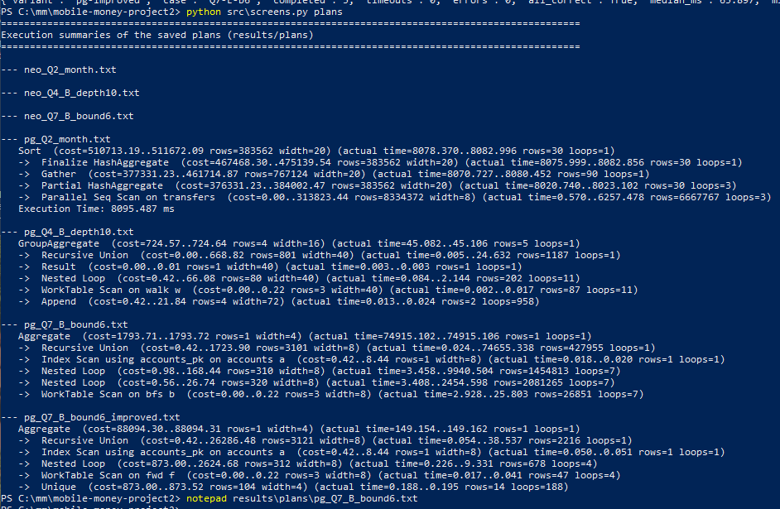
Execution summaries of the saved plans
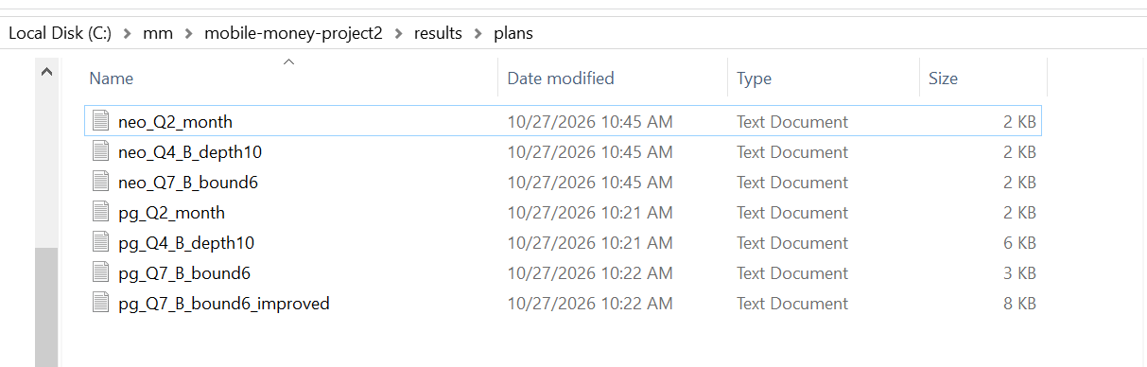
Saved plan files in results/plans
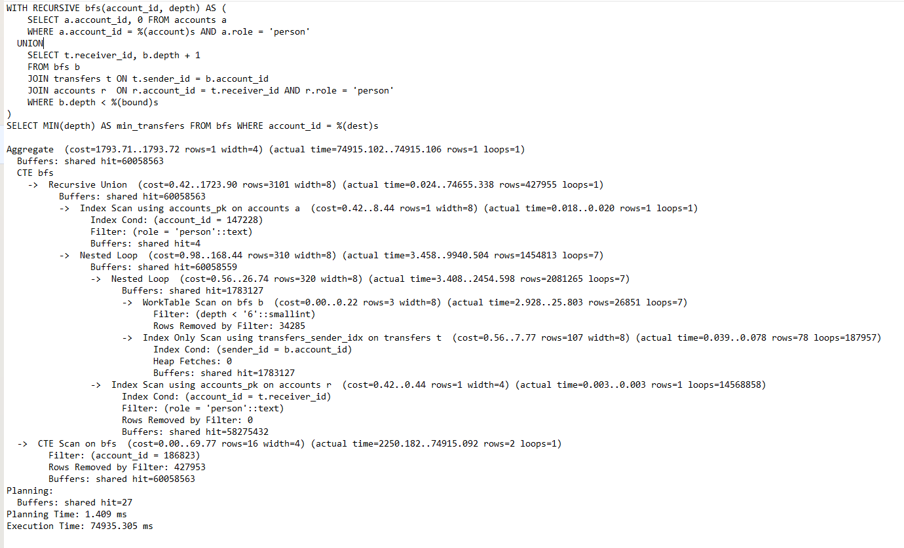
PostgreSQL plan for Q7 B bound 6 (baseline)
PROFILE MATCH (a:Account {account_id:147228}), (d:Account {account_id:186823})
OPTIONAL MATCH p = shortestPath((a)-[:TRANSFER*1..6]->(d))
WHERE all(n IN nodes(p) WHERE n.role = 'person')
RETURN length(p) AS min_transfers
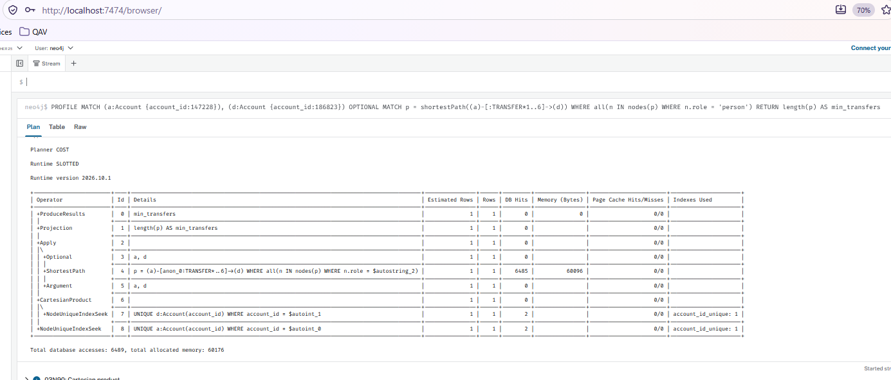
Neo4j PROFILE for Q7 B bound 6
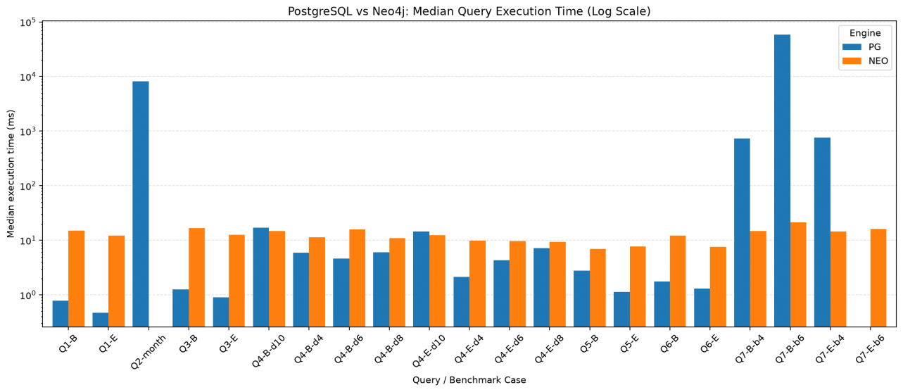
Median query time per case (log scale)
Insights
- PostgreSQL is about 3–25$×$ faster on the single-account look-ups (Q1, Q3, Q5, Q6) and Q4 is roughly even, but Neo4j wins Q7, where baseline SQL takes 0.7–58 s against Neo4j’s 15–21 ms.
- Q2 shows the opposite: PostgreSQL scans the full month in about 8.2 s, while Neo4j timed out in all five runs, so scanning and totalling every record favours the relational engine.

6.3 One SQL improvement
& "$env:NEO4J_HOME\bin\neo4j.bat" stop
python src\compare.py --engines pg --sql-q7 improved
python src\benchmark.py --engine pg --sql-q7 improved --only Q7
python src\benchmark.py --summarize
python src\screens.py plans
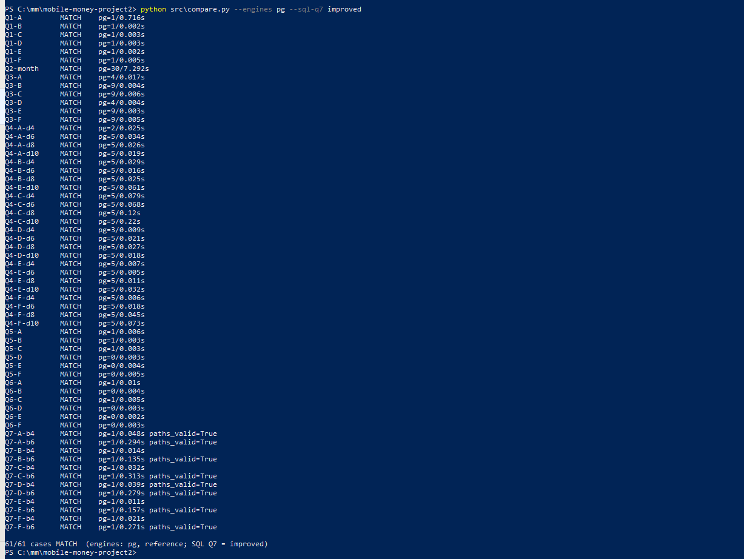
compare.py with the improved Q7 SQL
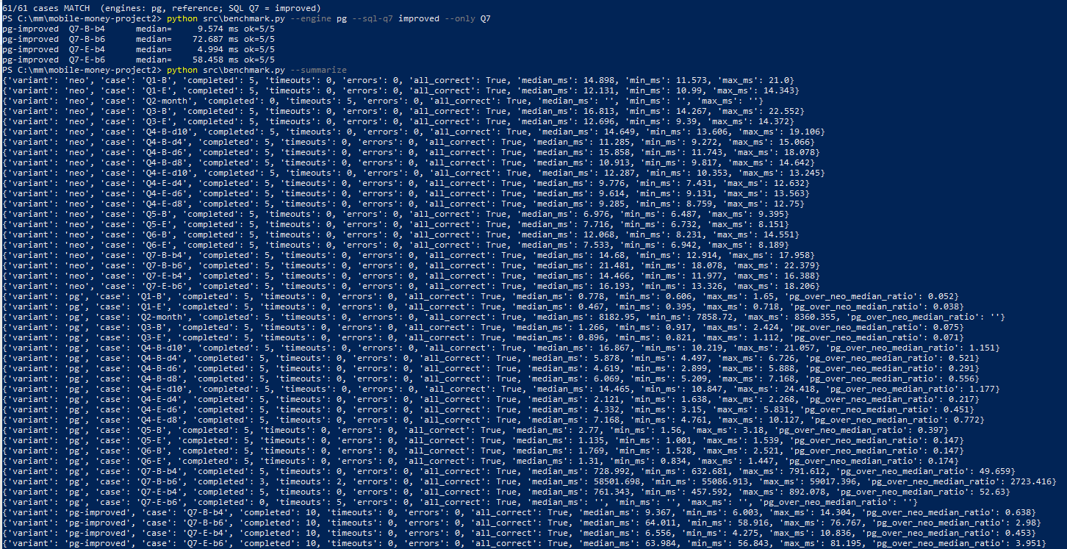
Benchmark of the improved Q7 SQL
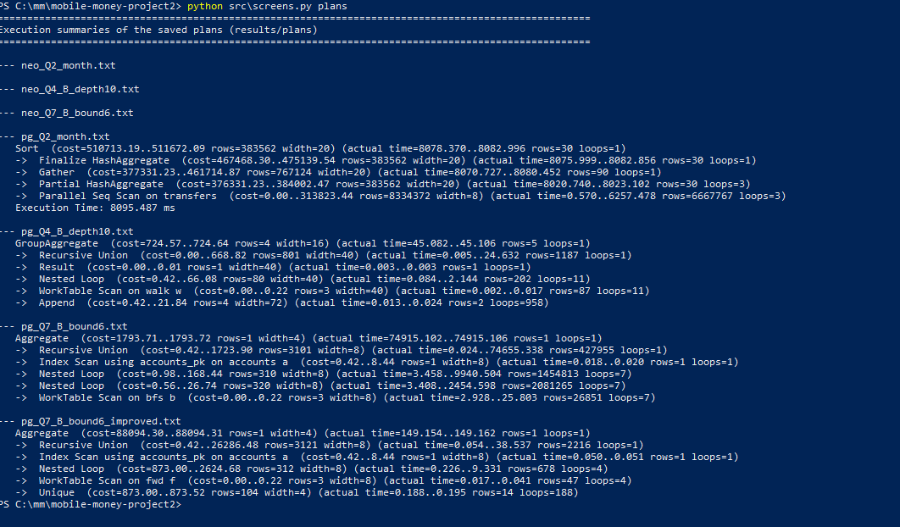
Plan summaries including pg_Q7_B_bound6_improved
Wasted work found in the baseline plan
Every frontier account re-reads all of its parallel transfers (78 per sender on average), accounts already reached are expanded again at later depths, and the search runs six levels from one side only. For Q7 B bound 6 the recursive union produced 427,955 rows and about 14.6 million index look-ups (74.9 s).
Prediction: searching from both ends over distinct person neighbours (forward up to half the bound, backward up to the other half, smallest sum where they meet) should cut the work by at least 100 times without changing any answer.
Result: all 61 cases still match, including the 12 Q7 cases with valid paths. The plan for Q7 B bound 6 fell from 74,935 ms to 151 ms with only 2,216 recursive rows. Medians:
- B bound 4: 729.0 ms $→$ 9.2 ms (about 80$×$ faster);
- B bound 6: 58,501.7 ms $→$ 60.2 ms (about 970$×$);
- E bound 4: 761.3 ms $→$ 9.2 ms (about 83$×$);
- E bound 6: timeout above 60 s $→$ 65.9 ms.
The improved version is used in Section 7 and in the final comparison. Both versions are kept in the code (Q7_SQL and Q7_SQL_IMPROVED).
python src\benchmark.py --summarize
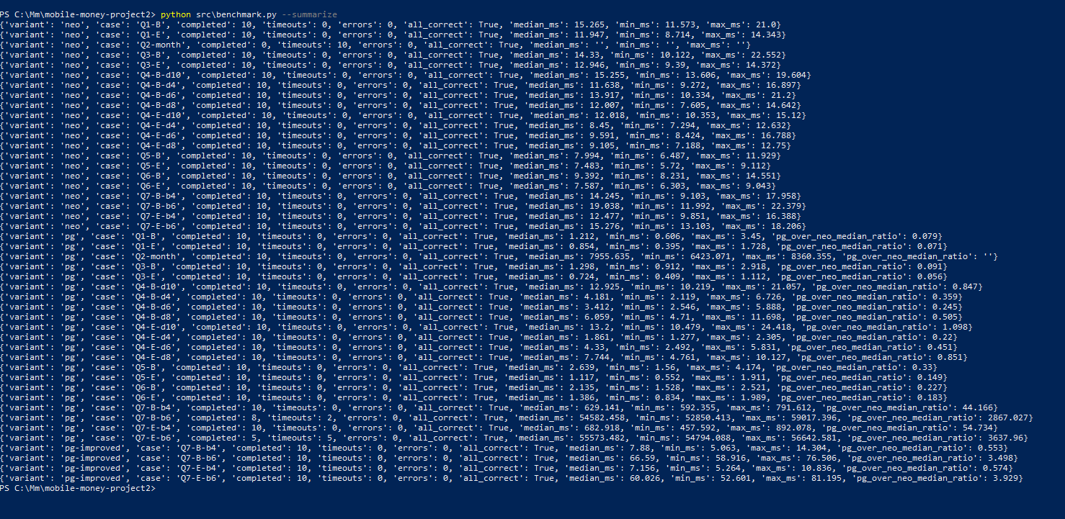
Final benchmark summary

7 Concurrent Requests

7.1 Load test
cd C:\mm\mobile-money-project2
del results\loadtest_*.csv
del results\loadtest_pg_log.txt
& "C:\NEO4J\bin\neo4j.bat" stop
Start-Service postgresql-x64-16
python src\loadtest.py --engine pg
Stop-Service postgresql-x64-16
& "C:\NEO4J\bin\neo4j.bat" start
python src\loadtest.py --engine neo
Start-Service postgresql-x64-16
python src\loadtest.py --summarize
python src\plots.py
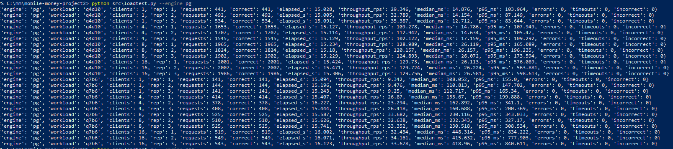
PostgreSQL load test
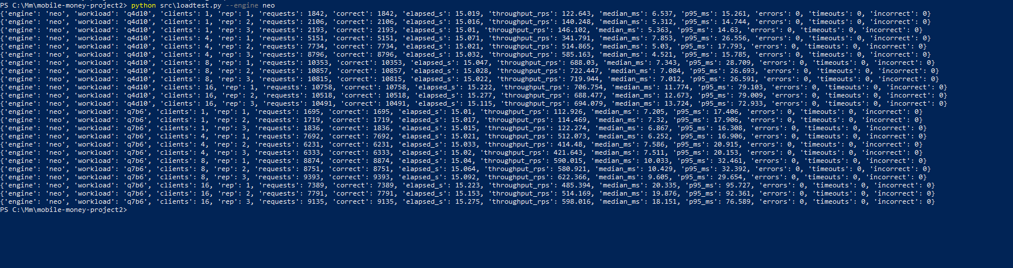
Neo4j load test
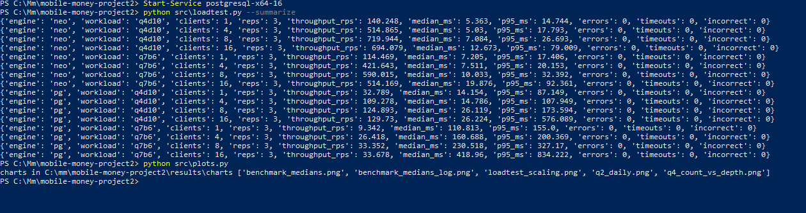
Load-test summary
Load test, medians of 3 repetitions (15 s window, cycles A-B-C, 60 s query limit)
Engine | Workload | Clients | Req/s | Median ms | p95 ms | Errors | Timeouts | Incorrect
Engine | Workload | Clients | Req/s | Median ms | p95 ms | Errors | Timeouts | Incorrect
pg | q4d10 | 1 | 32.789 | 14.154 | 87.149 | 0 | 0 | 0
pg | q4d10 | 4 | 109.278 | 14.786 | 107.949 | 0 | 0 | 0
pg | q4d10 | 8 | 124.893 | 26.119 | 173.594 | 0 | 0 | 0
pg | q4d10 | 16 | 129.730 | 26.224 | 576.089 | 0 | 0 | 0
pg | q7b6 | 1 | 9.342 | 110.813 | 155.000 | 0 | 0 | 0
pg | q7b6 | 4 | 26.418 | 160.688 | 200.369 | 0 | 0 | 0
pg | q7b6 | 8 | 33.352 | 230.518 | 327.170 | 0 | 0 | 0
pg | q7b6 | 16 | 33.678 | 418.960 | 834.222 | 0 | 0 | 0
neo | q4d10 | 1 | 140.248 | 5.363 | 14.744 | 0 | 0 | 0
neo | q4d10 | 4 | 514.865 | 5.030 | 17.793 | 0 | 0 | 0
neo | q4d10 | 8 | 719.944 | 7.084 | 26.693 | 0 | 0 | 0
neo | q4d10 | 16 | 694.079 | 12.673 | 79.009 | 0 | 0 | 0
neo | q7b6 | 1 | 114.469 | 7.205 | 17.406 | 0 | 0 | 0
neo | q7b6 | 4 | 421.643 | 7.511 | 20.153 | 0 | 0 | 0
neo | q7b6 | 8 | 590.015 | 10.033 | 32.392 | 0 | 0 | 0
neo | q7b6 | 16 | 514.169 | 19.876 | 92.361 | 0 | 0 | 0

7.2 Scaling
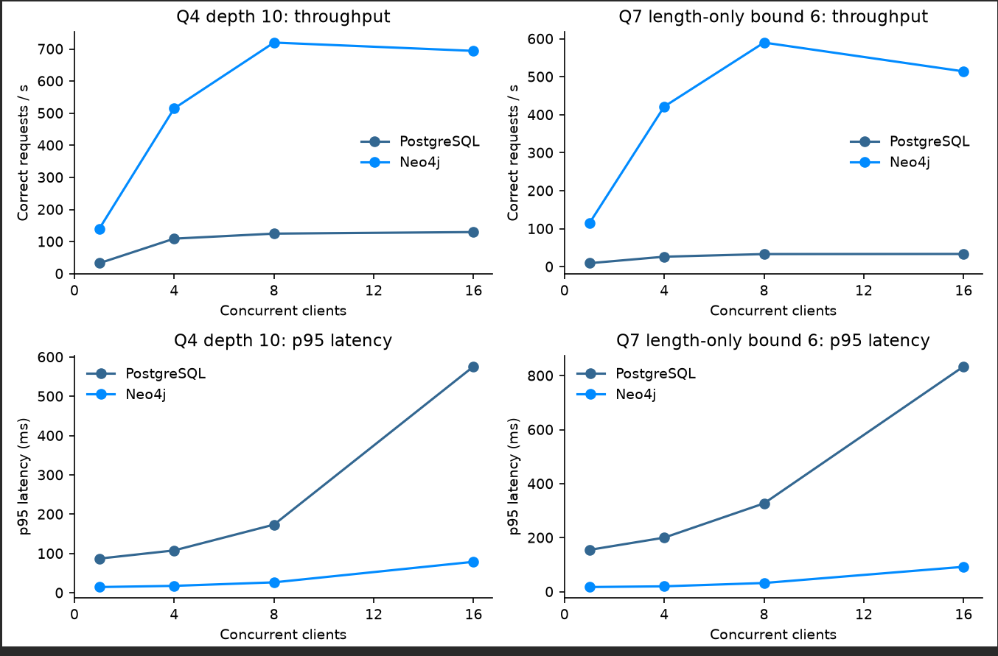
Throughput and p95 latency against the number of clients
Summary
- Neo4j sustained far higher throughput: at 16 clients 694 vs 130 req/s for Q4 ($≈5×$) and 514 vs 34 req/s for Q7 ($≈15×$).
- Both engines peak at about 8 clients, matching the 8 logical CPUs: PostgreSQL flattens (125$→$130, 33$→$34 req/s) and Neo4j dips slightly after 8 (720$→$694, 590$→$514 req/s); extra clients only queue.
- PostgreSQL p95 latency rose sharply from 1 to 16 clients (Q4 87$→$576 ms, Q7 155$→$834 ms) while Neo4j stayed under 100 ms (15$→$79, 17$→$92 ms).
- All 48 repetitions completed with 0 errors, 0 timeouts and 0 incorrect answers in both engines.
The improved SQL was close to Neo4j for one request at a time (Section 6.3), but under 16 concurrent clients Neo4j still served 5 to 15 times more correct requests per second with p95 latency below 100 ms. On our machine the graph advantage for these connected searches survives the SQL improvement.

8 Decisions

8.1 Investigation priority
Paired evidence and review priority
Pair | Q3 shared devices | Q4 network (10 links) | Q5 / Q6 | Q7 (bound 6) | Review first
A / D | Each shares one handset with its 3 group members for days 0 to 29, plus its own customer’s wallet | A 187, D 192 | A: 1 chain and a 4-transfer cycle (200,000 RWF in 2 min). D: none | A 3, D 3 | A
B / E | Each: household phone (5 customers) and one group device | B 228, E 230 | B: 1 chain of 1,050,000 RWF in 80 s. E: none | B 5, E 5 | B
C / F | Each: household phone (one member replaced a phone on day 11) and one group device | C 1,433, F 1,426 | C: 1 chain and a 6-transfer cycle (300,000 RWF in 3 min 20 s). F: none | C 5, F 5 | C

8.1.0.1 Detailed pair: A and D.
The device and network evidence cannot separate them. Each shares one handset with exactly its three group members for the whole month and reaches a similar number of accounts (187 and 192 at 10 links). The transfers are what differ. A sent 200,000 RWF to 8917 at 10:00:00 on 6 September. It was passed on to 16836 (196,000) and 24755 (192,080) at 40-second intervals and came back to A as 188,238 RWF at 10:02:00, a closed loop losing 2 % at each hop. D’s group passed 45,000 RWF around the same kind of four-account loop (transfers 20001651 to 20001654), but two days apart (6, 8, 10 and 12 September) and with equal amounts. That fails the 600 s and 1,800 s windows and looks like a rotating savings group (ikimina) or family support. We would review A first.

8.1.0.2 Ordinary explanation for A.
Four colleagues sharing one shop phone could pass a float between them to settle a joint purchase, each keeping a 2 % commission. Missing evidence would decide it: balances, KYC links between the owners, who started each payment, and what happened to the 188,238 RWF afterwards. If the owners turn out to be one business with a documented float, the concern falls away; if the money left through an agent soon after returning, the priority rises. These records justify enquiries, not a finding of fraud.
Transfer cycle of set A (from Section 4.3)
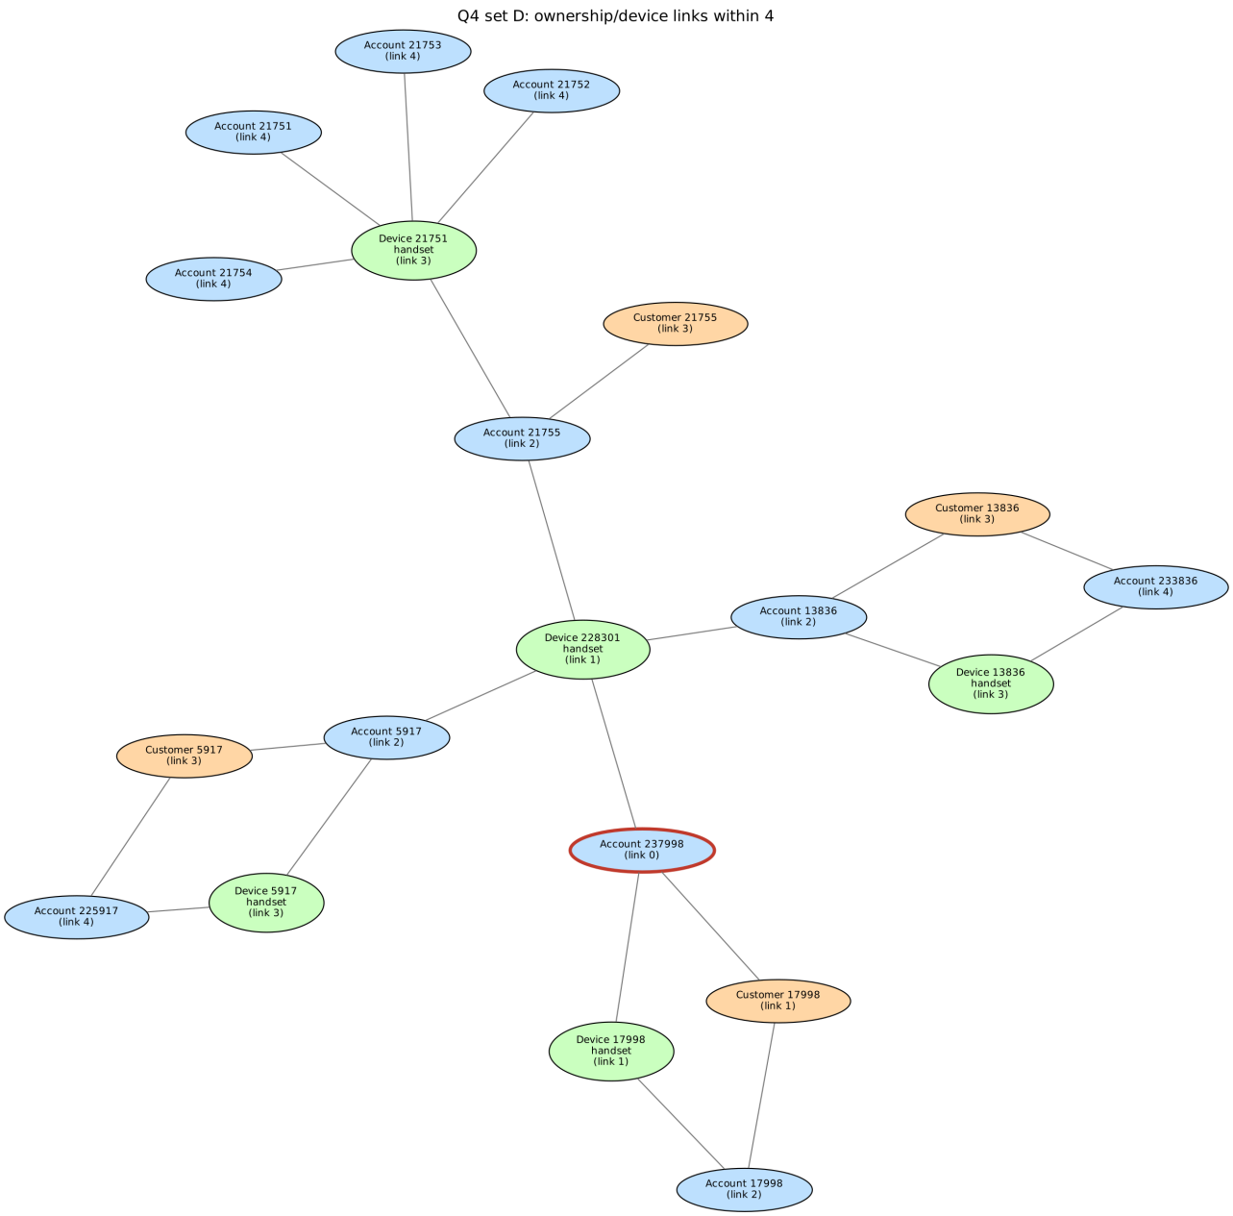
Ownership and device network of set D within four links

8.2 Model recommendation ($≤$ 500 words)
Recommendation
Keep PostgreSQL as the system of record and for routine reporting, and add Neo4j as a read-only copy for connected-account investigations.

8.2.0.1 Reporting (Q1 to Q3).
PostgreSQL answered the single-account questions in 0.5 to 2.8 ms against 7 to 17 ms in Neo4j, and the month summary (Q2) in 8.2 s. Its plan is a parallel sequential scan with hash aggregation. Neo4j scanned all 20,003,300 TRANSFER relationships, converted every timestamp (about 40 million database hits) and timed out in all five benchmark runs. Loading was also simpler in PostgreSQL (46.8 s plus 310.7 s for keys and indexes, 3.73 GB) although the Neo4j import was fast too (109.7 s plus about 96.5 s for constraints, 2.05 GB).

8.2.0.2 Traversal (Q4 to Q7).
The baseline SQL for Q7 needed 0.73 s at bound 4 and 58.5 s or a timeout at bound 6, while Neo4j’s shortest path took 14 to 21 ms. However, our improved SQL brought Q7 down to 9 to 66 ms. Most of the original gap therefore came from the search algorithm, not from the data model. The real modelling benefits are that relationships are stored as direct links, variable-length patterns and shortest paths are built in, and the Cypher queries are much shorter and easier to check. Q4 at depth 10 was about equal for one user (16.9 ms against 14.6 ms).

8.2.0.3 Concurrency.
This is where Neo4j’s advantage remained. At 16 clients it served 694 against 130 requests per second for Q4 and 514 against 34 for Q7, with p95 latency below 100 ms against 576 and 834 ms in PostgreSQL.

8.2.0.4 Evidence against our choice.
A second database needs a copy pipeline, monitoring and memory tuning; PostgreSQL was faster for every look-up and was the only engine that completed Q2; and the improved SQL beat Neo4j at bound 4 (9.2 ms against 14.5 ms). If investigation volume stays low, PostgreSQL alone with the improved SQL may be enough.

8.2.0.5 Freshness.
We propose copying new transfers to Neo4j at least every 15 minutes, by loading transfer_ids above the last one copied. The Q5 window is only 10 minutes, so stale data would miss chains and cycles that involve the newest transfers. Any alert on very recent activity should therefore be confirmed in PostgreSQL before action.

8.2.0.6 Limits.
One synthetic month on one 8-thread laptop with Neo4j at default memory settings, and no write workload or replication was measured.

8.3 Individual judgement

Mushambo Godfrey – Q7 baseline against improved SQL
- B bound 6: 58,501.7 ms $→$ 60.2 ms (about 970$×$ faster).
- E bound 6: timed out (over 60 s) $→$ 65.9 ms.
- Neo4j took 21.5 / 16.2 ms. All 12 Q7 cases still match.
- Plan for B bound 6: 427,955 rows and about 14.6 million index look-ups (74.9 s), down to 2,216 rows (151 ms).
& "$env:NEO4J_HOME\bin\neo4j.bat" stop
python src\q7_extra_pairs.py --engine pg # about 10 min
Stop-Service postgresql-x64-16
& "$env:NEO4J_HOME\bin\neo4j.bat" start
python src\q7_extra_pairs.py --engine neo
- python src\q7_extra_pairs.py --summary # screenshot this

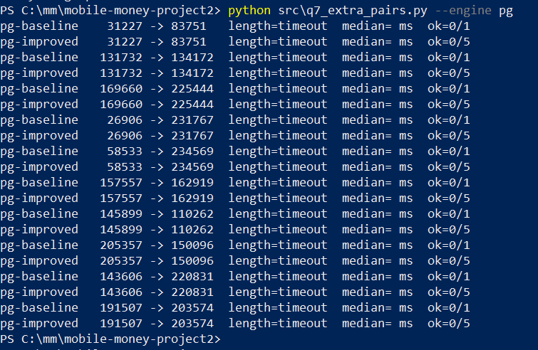
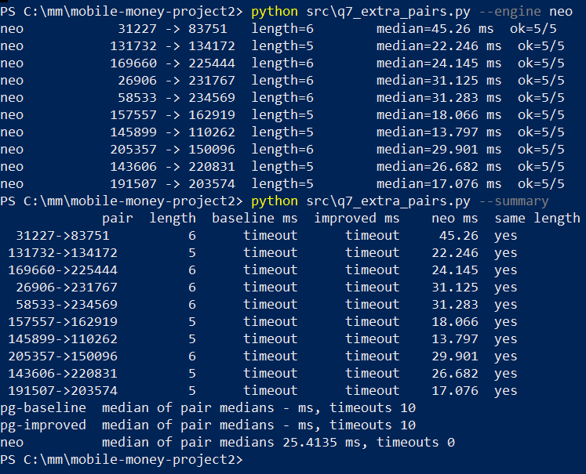

Manzi Shima Christian – Load-test saturation at about 8 clients
Get-CimInstance Win32_Processor | Select-Object Name, NumberOfCores, NumberOfLogicalProcessors

- PostgreSQL Q4 throughput: 33 $→$ 109 $→$ 125 $→$ 130 req/s at 1 $→$ 4 $→$ 8 $→$ 16 clients; p95 87 $→$ 576 ms.
- Neo4j: 140 $→$ 515 $→$ 720 $→$ 694 req/s.
- No errors, timeouts or wrong answers in any of the 48 repetitions.
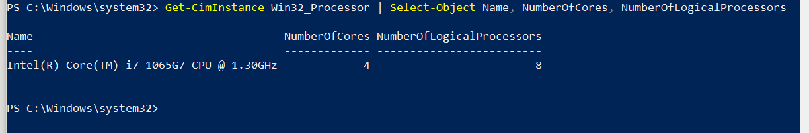
CPU cores and logical processors (saturation point at 8 logical CPUs)

Mutoni Scovia – Q4 growth with depth
& "C:\Program Files\PostgreSQL\16\bin\psql.exe" -U postgres -d mobile_money -f sql\q4_weak_links.sql

- At 4/6/8/10 links: C goes 146 $→$ 483 $→$ 832 $→$ 1,433 and F 147 $→$ 488 $→$ 837 $→$ 1,426, while A, B, D, E level off around 187–230.
- 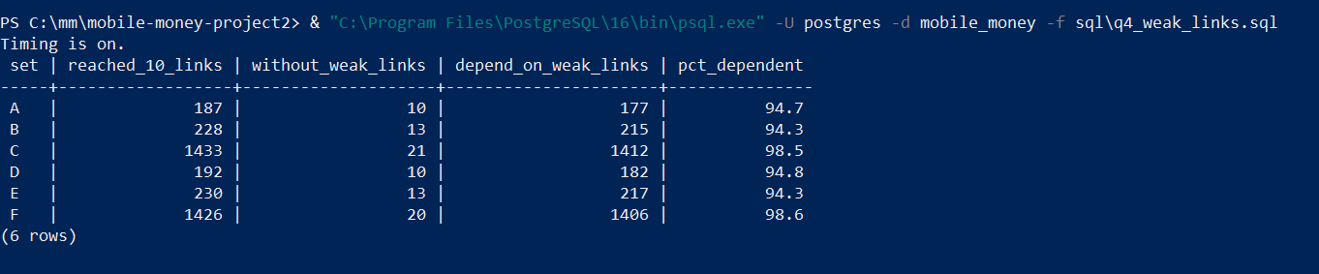
Member | Contributions | /external assistance and how it was checked
Mushambo Godfrey | Contributes on the whole project mostly on system preparations | Using: 1. LLM: Chatgpt, claude, Meta AI, google Ai  2. community:  - https://neo4j.com/deployment-center/?gdb-selfmanaged&community  - https://www.postgresql.org/  - Recturers Notes
Shimwa Christian | Contributes on the whole project mostly on scripts and codes | Using: 1. LLM: Chatgpt, claude, Meta AI, google Ai  2. community:  - https://neo4j.com/deployment-center/?gdb-selfmanaged&community  - https://www.postgresql.org/  - Recturers Notes
Mutoni Scovia | Contributes on the whole project mostly focused on interpretation results, graphs, | Using: 1. LLM: Chatgpt, claude, Meta AI, google Ai  2. community:  - https://neo4j.com/deployment-center/?gdb-selfmanaged&community  - https://www.postgresql.org/  - Recturers Notes

9 Reproducibility
Both services were stopped at the end (Get-Service postgresql-x64-16 and neo4j.bat status).
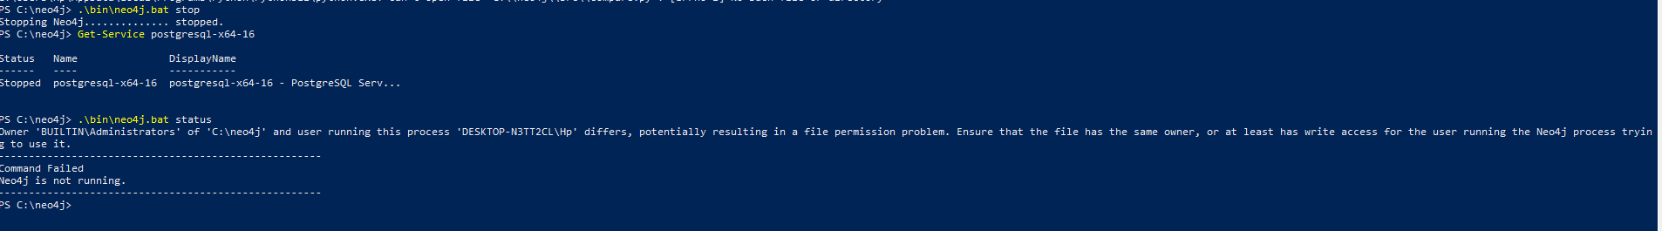
Both services stopped
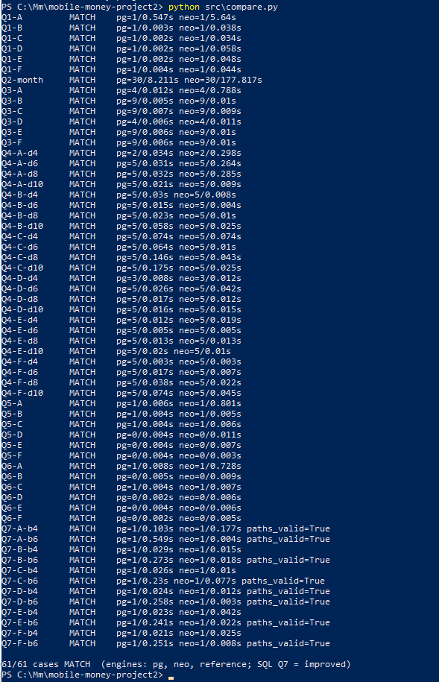
Final compare.py run: 61/61 cases MATCH

